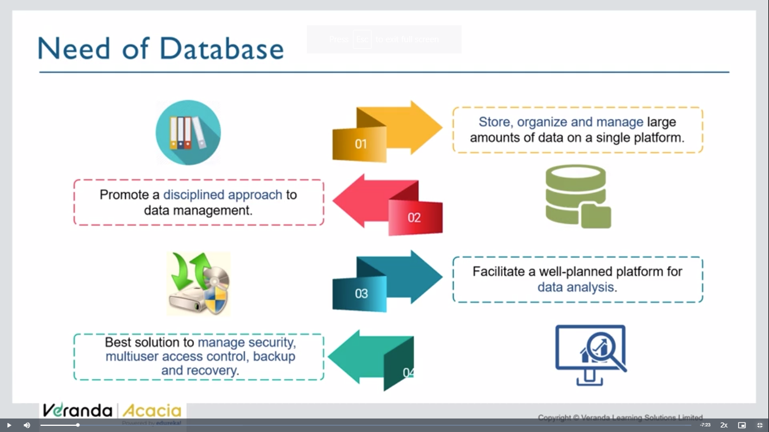

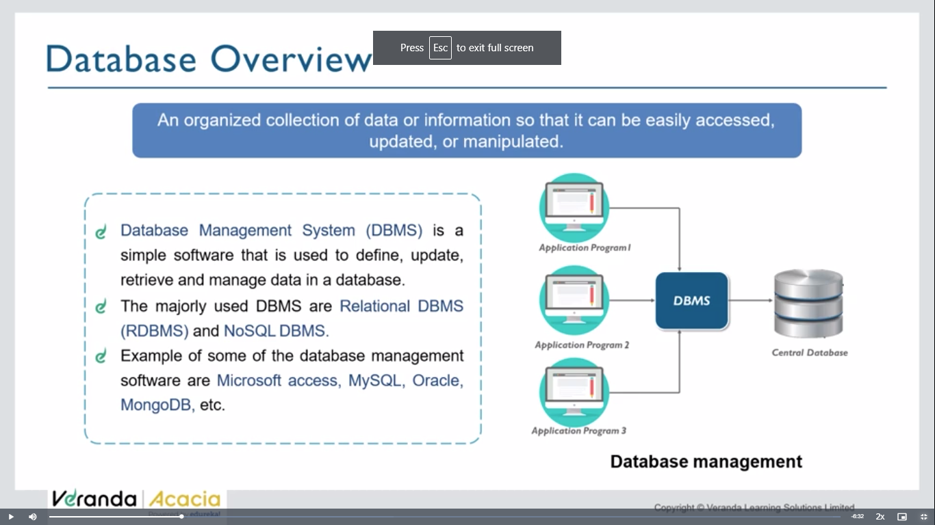

We do 4 operations on db- CRUD

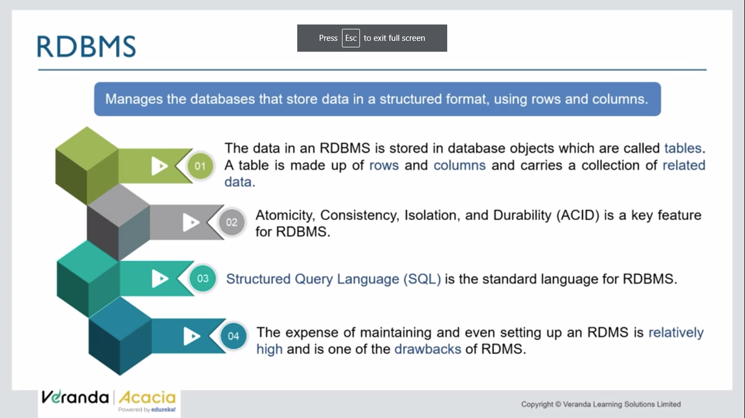

ACID is an acronym that refers to the set of 4 key properties that define a transaction: **Atomicity, Consistency, Isolation,** and **Durability.** If a database operation has these ACID properties, it can be called an ACID transaction, and data storage systems that apply these operations are called transactional systems. ACID transactions guarantee that each read, write, or modification of a table has the following properties:

* **Atomicity** - each statement in a transaction (to read, write, update or delete data) is treated as a single unit. Either the entire statement is executed, or none of it is executed. This property prevents data loss and corruption from occurring if, for example, if your streaming data source fails mid-stream.

Atomicity – one task must be fully completed or fully aborted

* **Consistency** - ensures that transactions only make changes to tables in predefined, predictable ways. Transactional consistency ensures that corruption or errors in your data do not create unintended consequences for the integrity of your table.
* **Isolation** - when multiple users are reading and writing from the same table all at once, isolation of their transactions ensures that the concurrent transactions don't interfere with or affect one another. Each request can occur as though they were occurring one by one, even though they're actually occurring simultaneously.
* **Durability** - ensures that changes to your data made by successfully executed transactions will be saved, even in the event of system failure.

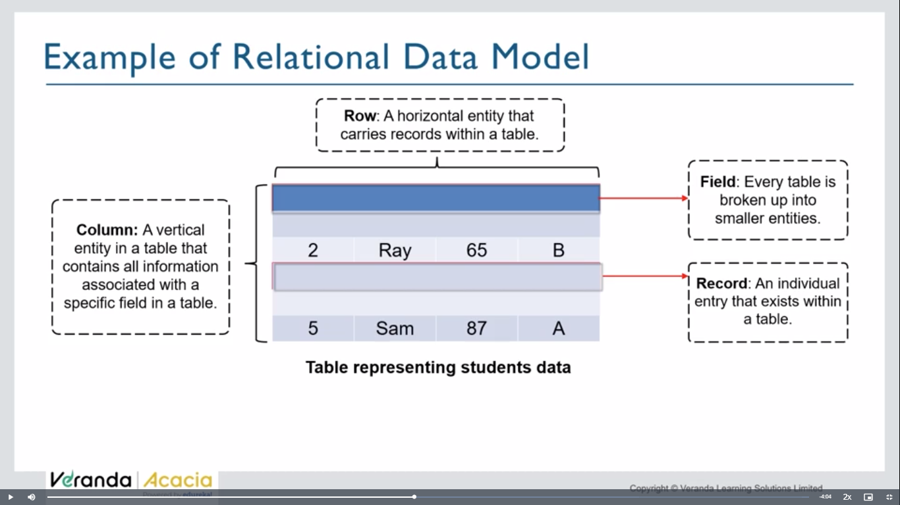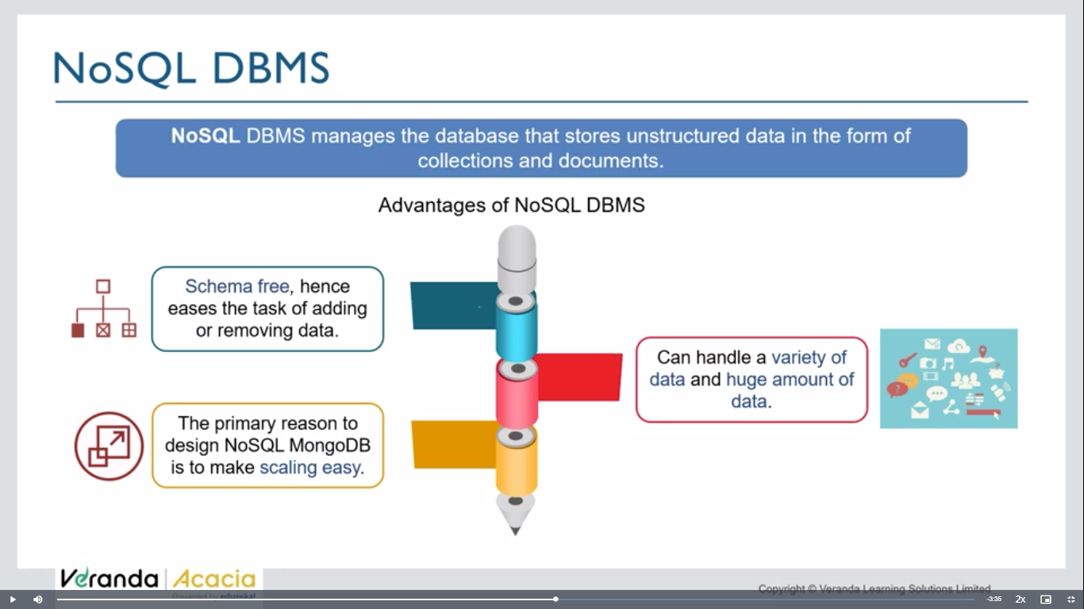

They don’t use db, can use docuemnts / any form

Rows in sql => collections in mongodb

Columns in sql => document s in mongodb.(key-value pairs)

{

Name: ‘zee’, //key-value pairs - documents

Age:23

},

{

Name:

}

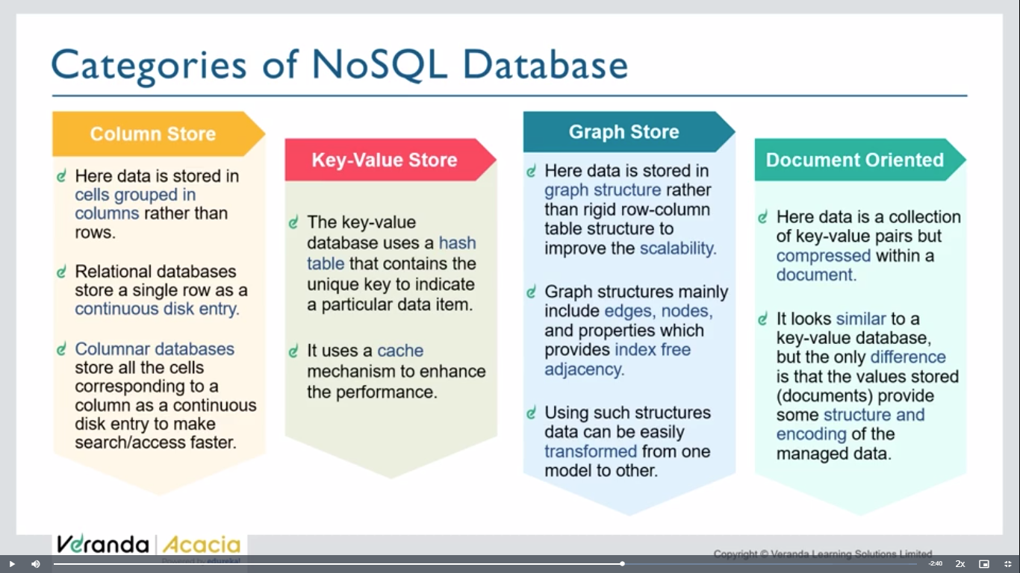

Data can be in above forms

Mongodb – document orientated db

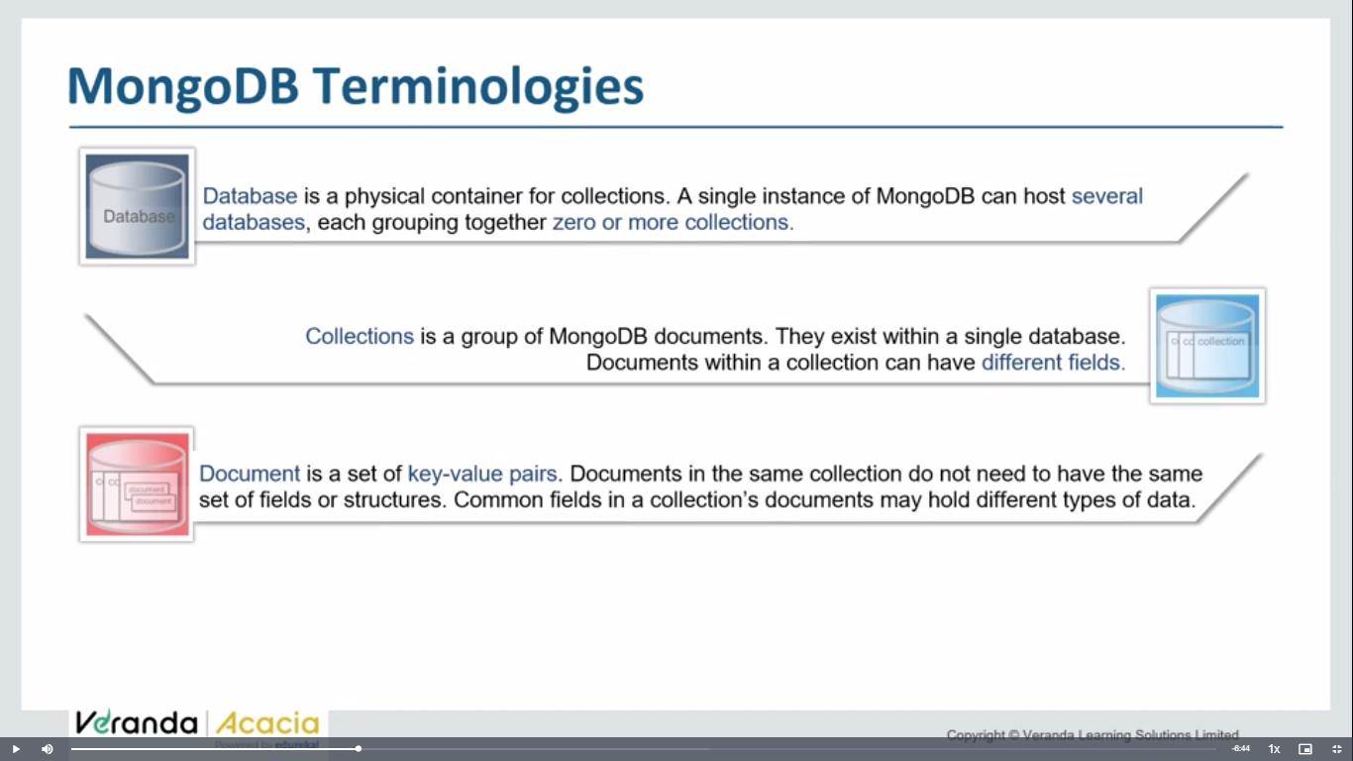

**Day 58: mongodb installation**

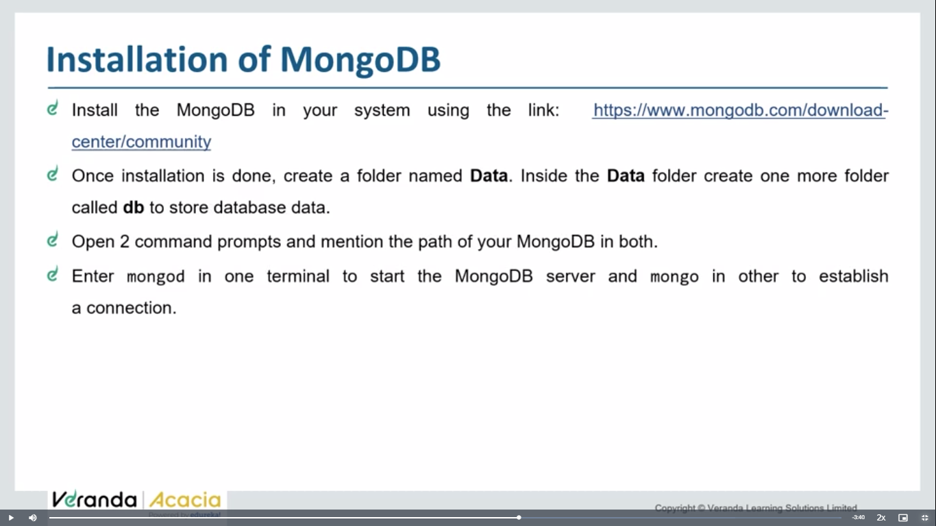

You can begin to download MongoDb from [here](https://www.mongodb.com/try/download/community).

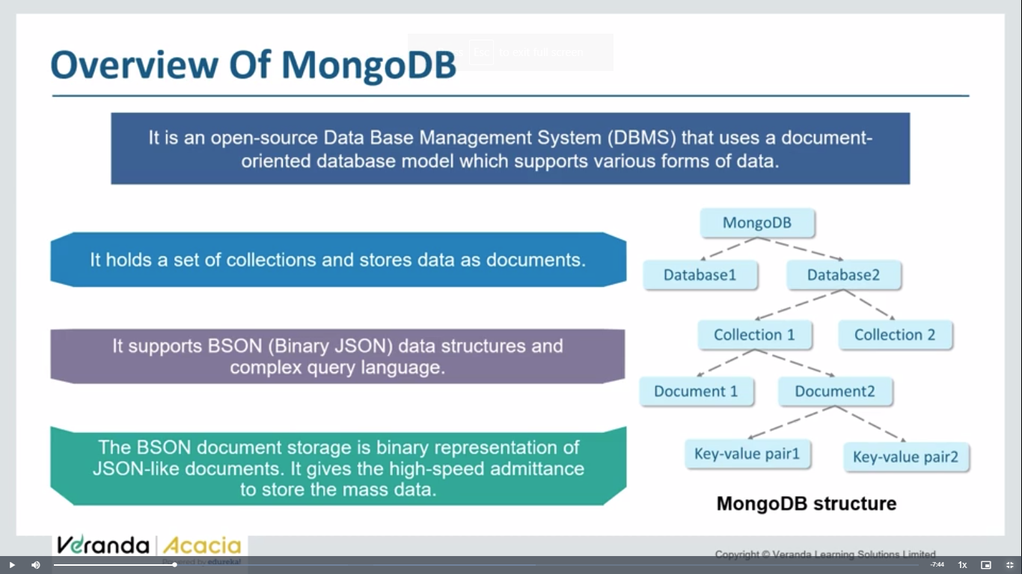

**Mongod- mongodb server**

**Mongosh- mongosh**

<https://www.mongodb.com/try/download/community>

download mongodb link

create datafolder in c drive and inside data create db folder

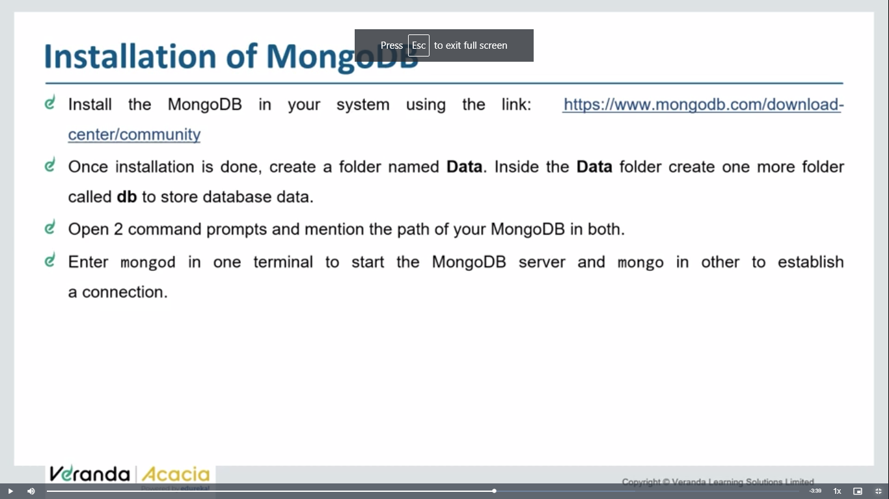

{

Objectid: ‘78739800494’,

Name:’zee’,

Age: ‘25’

},

{

Object id: ‘256636677655’,

Name:’uhuhf’

Age:’67’

}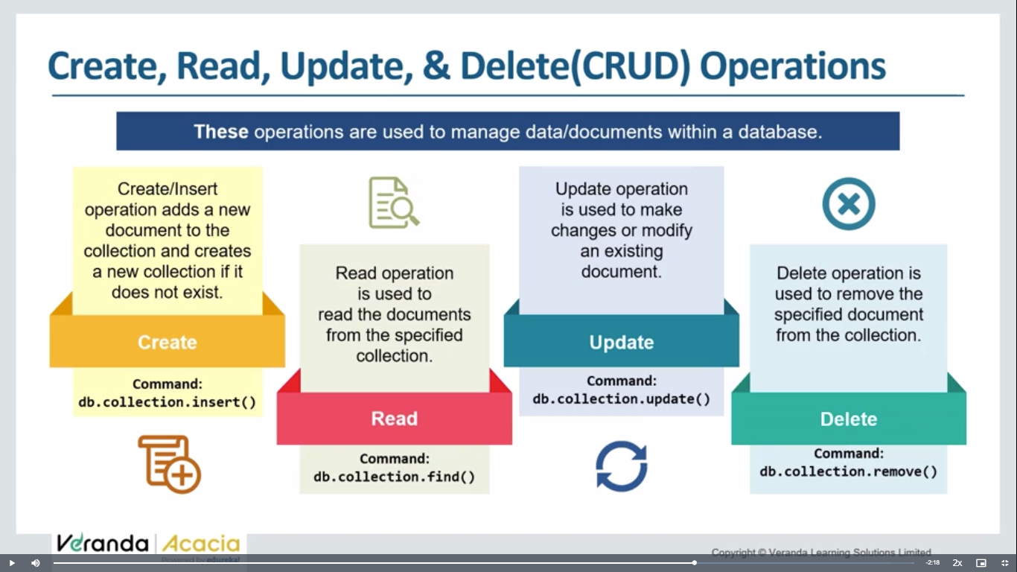 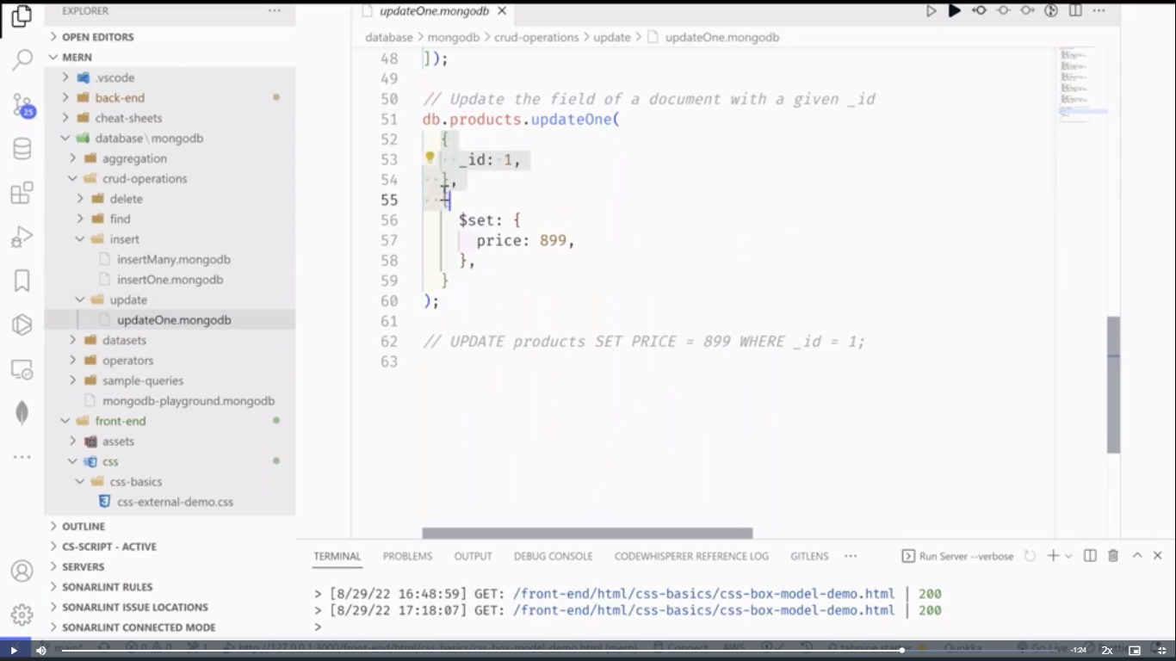 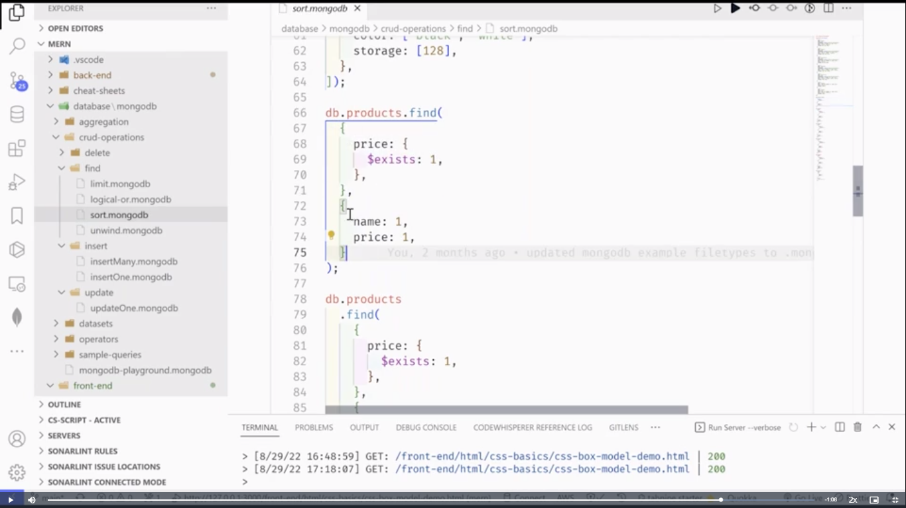 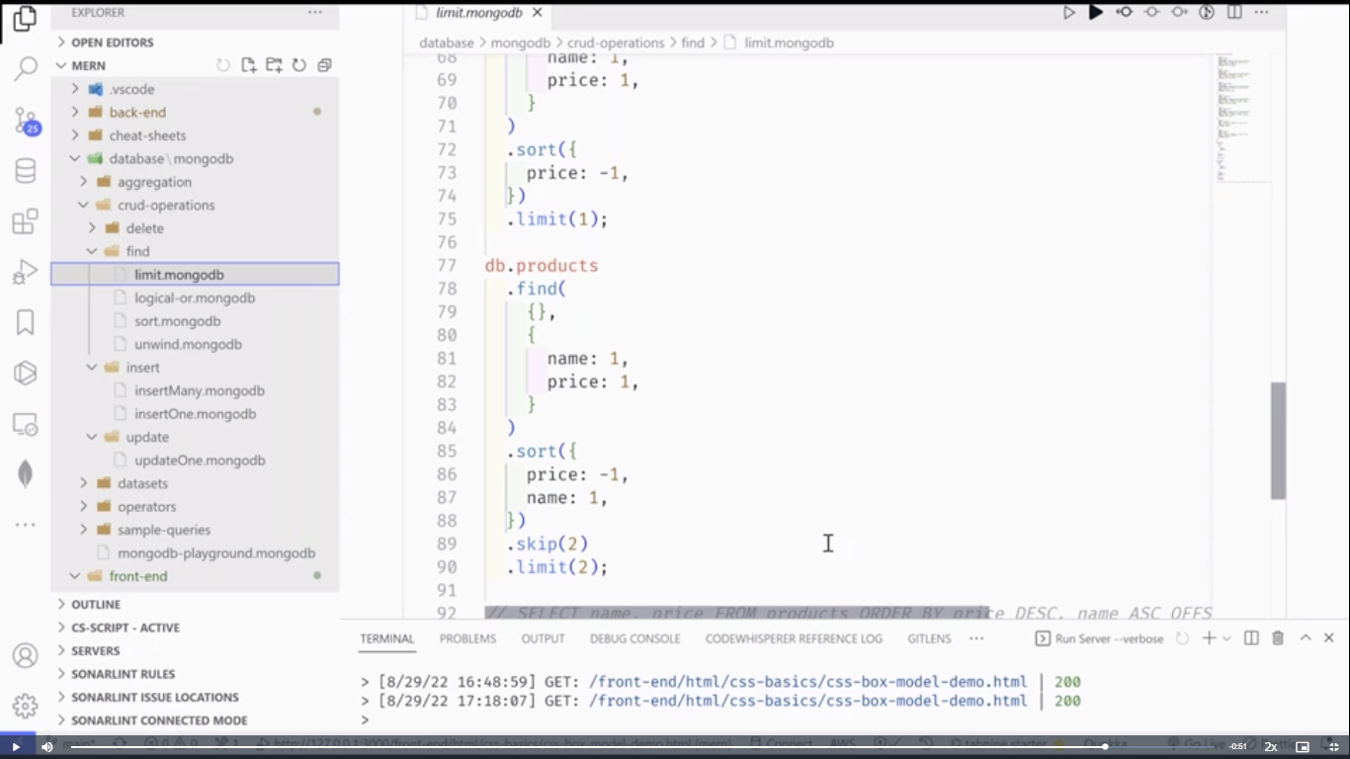

Day 58-lu2:

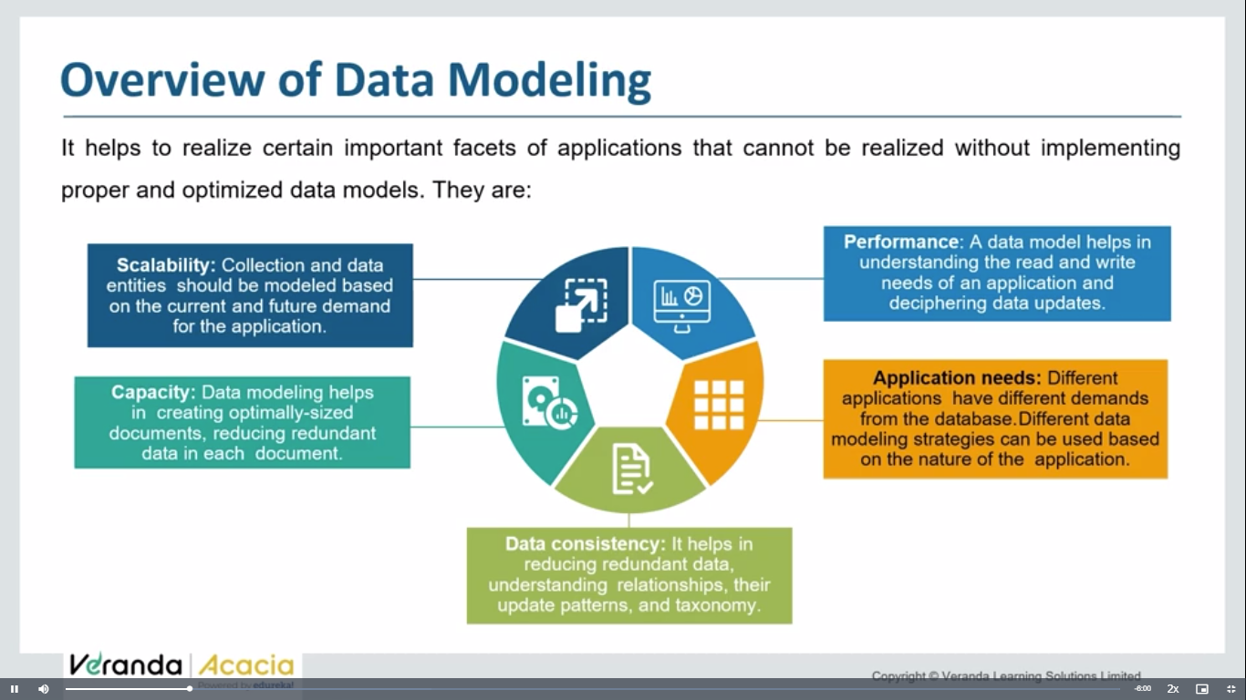

Choosing proper data models , according to business needs will helps with following:

Scalability, performance,capacity,data consistency,application needs

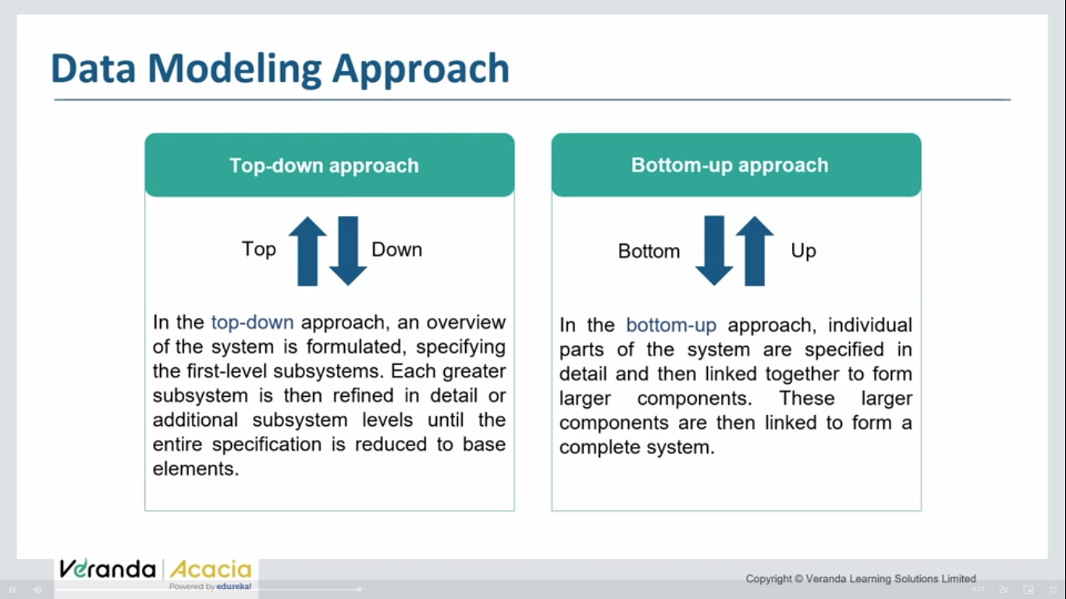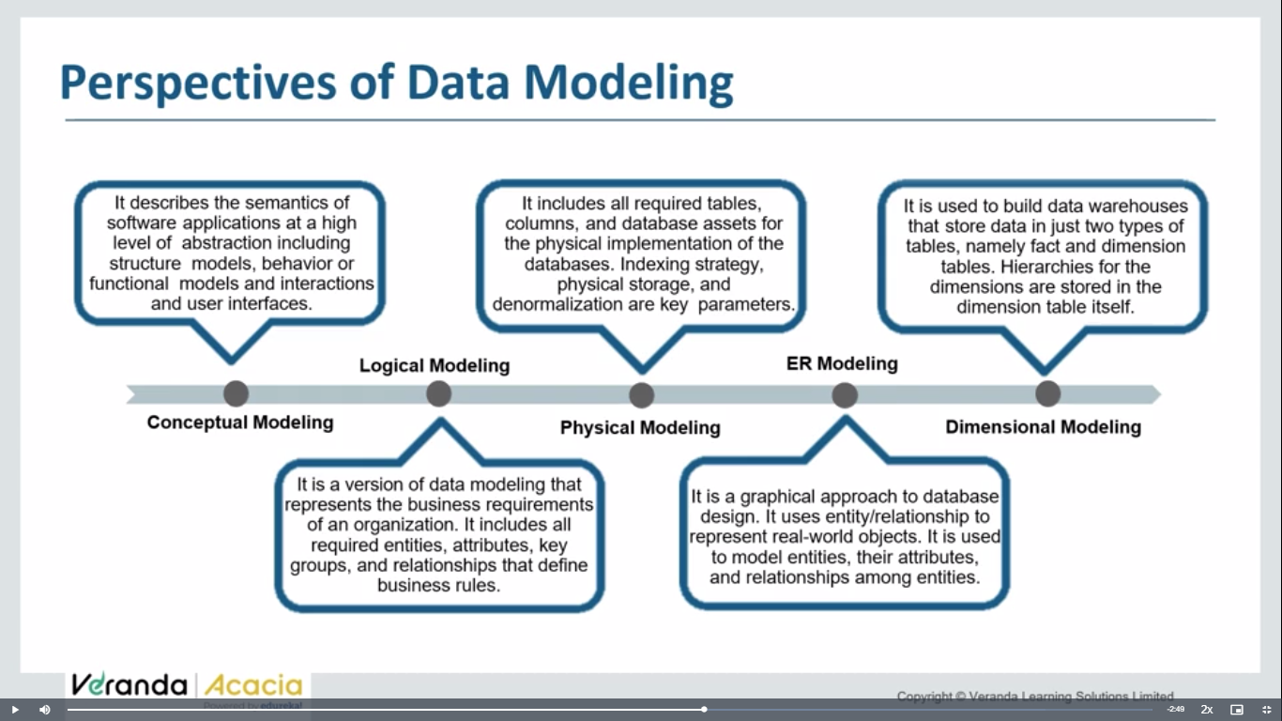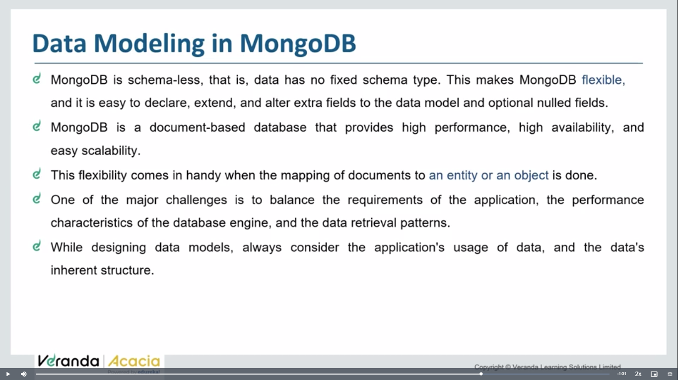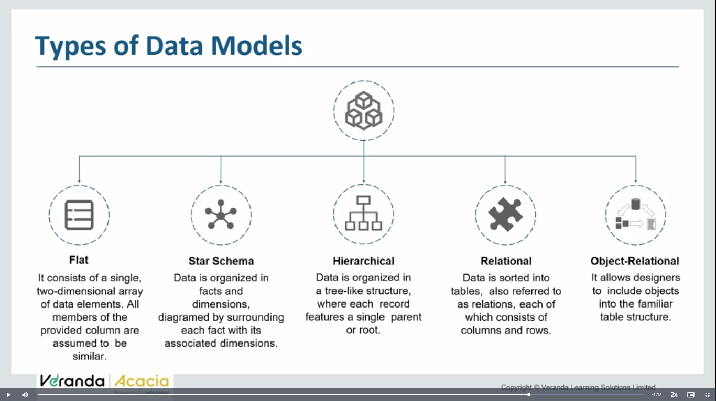

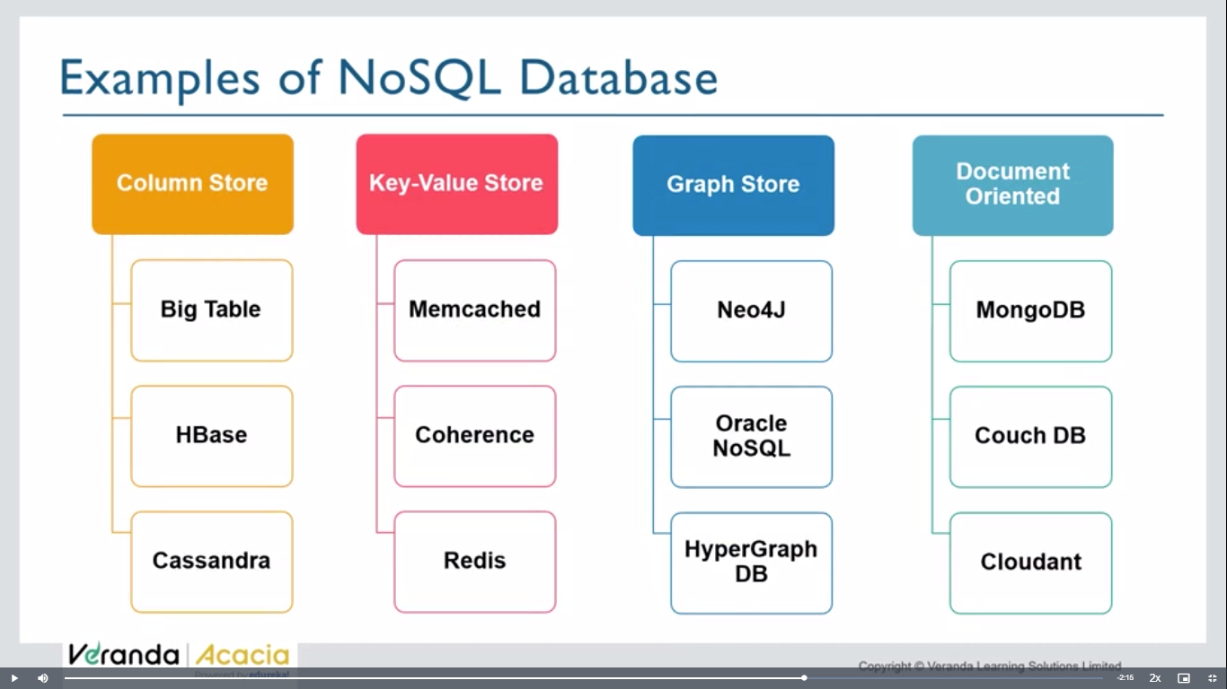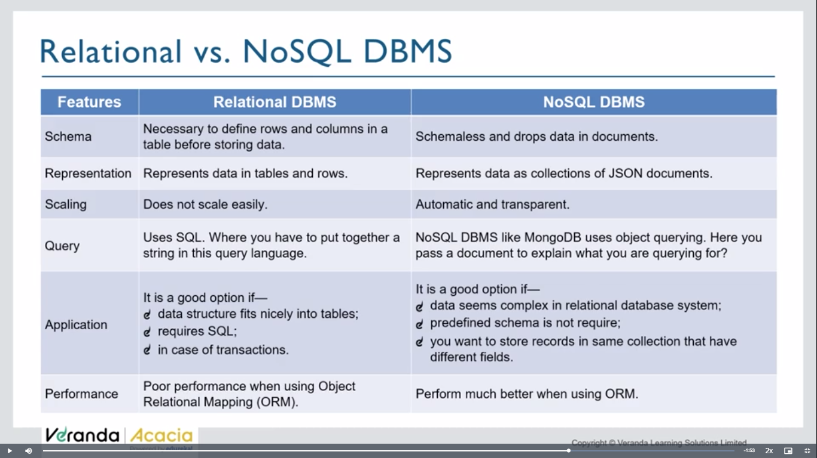

Sql – use if u need ur data in structured manner, and to work with trassacntions

Nosql= if ur data structure is complex, can be scale in future, no need of particular schema

**One way:**

**What is meant by a Document Oriented Database?**

Simply, a document oriented database means which stores its data in the form of documents.

* MongoDb stores data as documents, so it is known as a document oriented database.
* Data is stored in the form of BSON. BSON is almost similar to JSON with the only difference that types of variables are declared in it.
* If you are coming from the DBMS background, then following changes are there-

1. Database is referred to as a database.
2. Table is referred to as a collection.
3. Row is referred to as documents
4. **Binary vs. text**: BSON is a binary-encoded format, whereas JSON is a text-based format. This means that BSON is compact for transmitting over a network, while JSON is human-readable and easier to work with in various contexts.

**Bson -** Supports additional data types such as binary data and date types**{….}**

**Json -**

|  |
| --- |
| Supports strings, numbers, null, arrays, and objects |
|  |

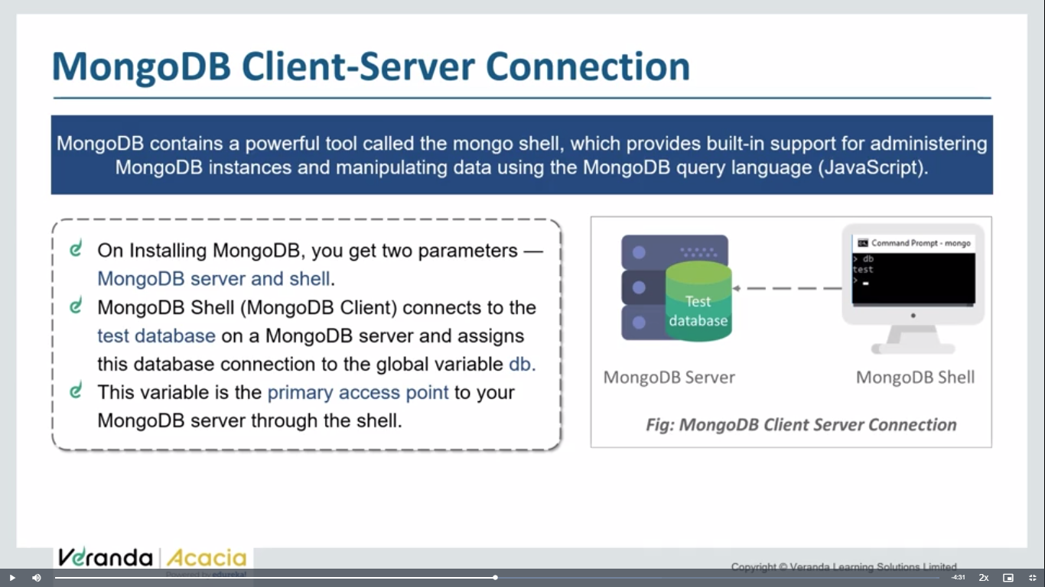

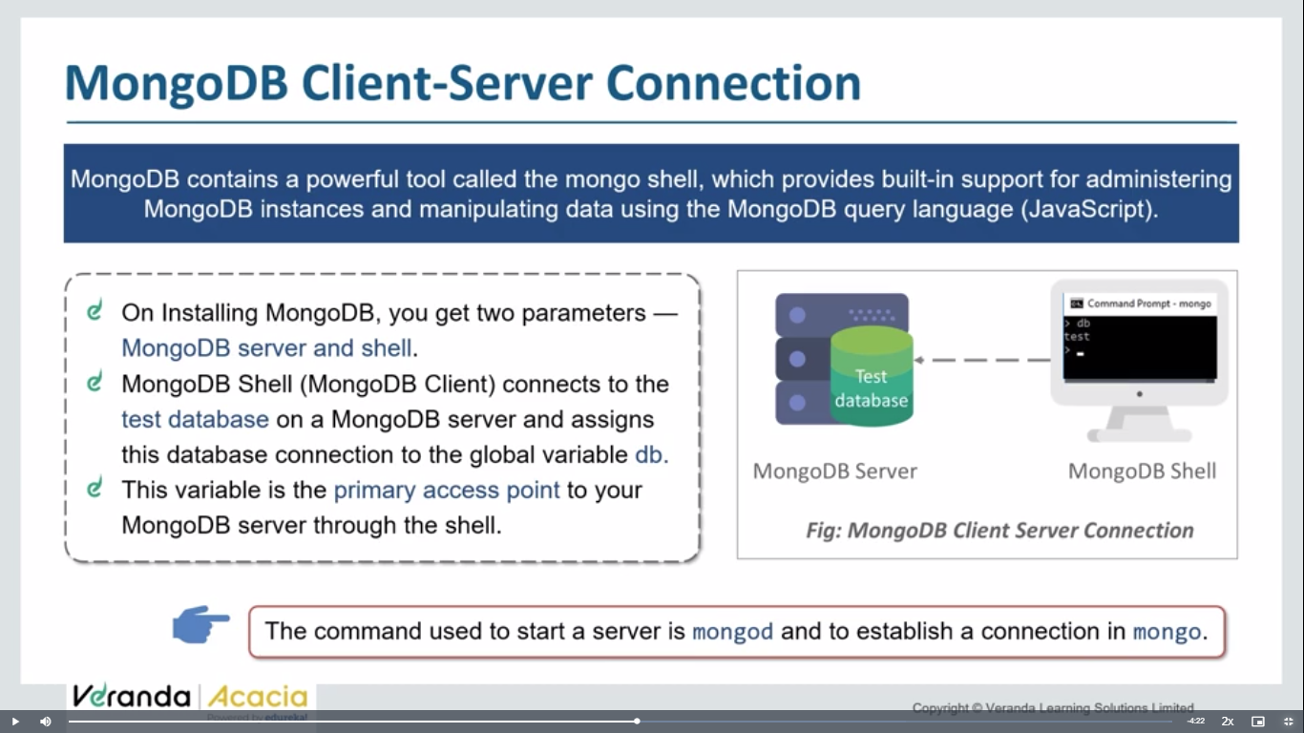

**mongodb crud operations:**

use harryKart

Copy

db.items.insertOne({name: "Samsung 30s", price: 22000, rating: 4.5, qty: 233, sold: 98})

Copy

db.items.insertMany([{name: "Samsung 30s", price: 22000, rating: 4.5, qty: 233, sold: 98}, {name: "Moto 30s", price: 29000, rating: 3.5, qty: 133, sold: 598}, {name: "Realme 80s", price: 129000, rating: 2.5, qty: 633, sold: 98, isBig: true}])

Copy

**db.items.find()**

Primary key here Is object id

**Searching and Querying data:**

// Searching for data in mongo db

use harryKart

// This query will return all the objects with rating equal to 3.5

db.items.find({rating: 3.5})

Copy

This function will return all those items that match the condition. However, we can also use some complex functions like greater than or less than to meet our query as follows-

db.items.find({rating: {$gt: 3.5}})

Copy

We can also use ***and***operator to meet our query. The example is as follows-

db.items.find({rating: {$gt: 3.5}, price:{$gt: 4000}})

Copy

This code will give the list of all those items having ratings greater than 3.5 and having prices more than 4000.

If we write as-

db.items.find({rating: {$lt: 3.5}, price:{$gt: 114000}})

Copy

We will get the output as the list of those items whose ratings are less than 3.5 and price more than 114000.

Till now you must have noticed that in the case of ***And*** operator, we have not used any symbol. But it is not the same in the case of ***Or***. While using *OR* operator, we will use a dollar ‘$’ symbol as follows-

db.items.find({

$or:[{rating: {$lt: 3.5}}, {price:{$gt: 114000}}]

})

It will give the list of all those items having rating less than 3.5 or price more than 114000 as follows-

show dbs

use harryKart

show collections

db.items.find({price: 22000})

// Deleting items from the Mongo Database

db.items.deleteOne({price: 22000})

// deleteOne will delete the matching document entry and will delete the first entry in case of multi document match

db.items.deleteMany({price: 129000})

**updating:**

db.items.updateOne({name: "Moto 30s"}, {$set: {price: 2}})

Copy

db.items.updateMany({name: "Moto 30s"}, {$set: {price: 3, rating: 1}})

Copy

The ***updateMany()*** function is used to update multiple items. Hence after writing the above code, we get the output as follows-

So the things that we were doing earlier with terminals, and command on MongoD, now we can do it by MongoDb Compass GUI.

**Sharding: sharing huge data into multiple databases.**

**Replicas: replicating same data into secondary dbs.**

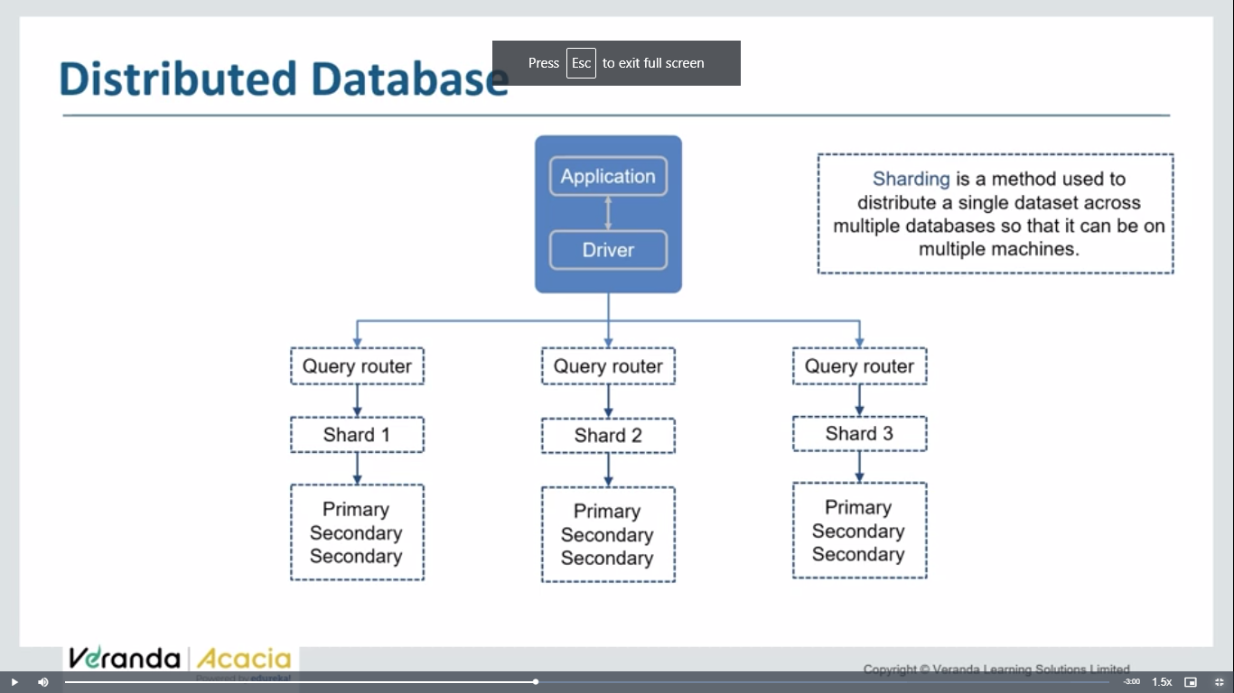

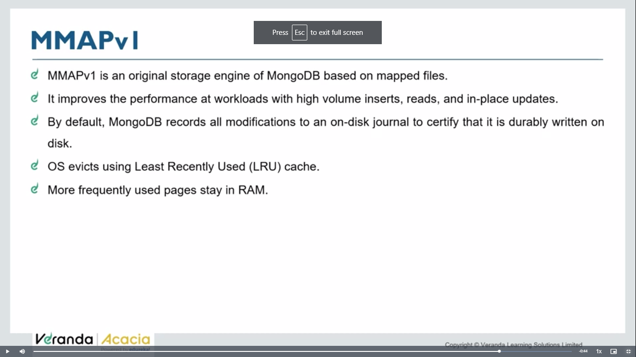

One point to note here is there is no need to write rating, price, or any other schemas while working with MongoDb compass. It provides you all types of flexibility. Also you can take help of filters to find your schemas as shown here-

Let us now see how to connect this MongoDb compass to Node.Js. We can do this with the help of ***Mongoose***. It is an object data modeling (ODM) library that provides a rigorous modeling environment for your data, enforcing structure as needed while still maintaining the flexibility that makes MongoDB powerful.

We will make a new folder as ***Mongoosetut***. We will open the terminal window and install npm. After installing the *package.json*file we will write ***npm install mongoose*** to install the mongoose.

You will get the output as follows-

**Mongodb tutorial:**

**Mongodb**  is a no sql db(not structured)

Data stored in a collection

Collection don’t have row and columns

Data is stored in form of object.(bson format)

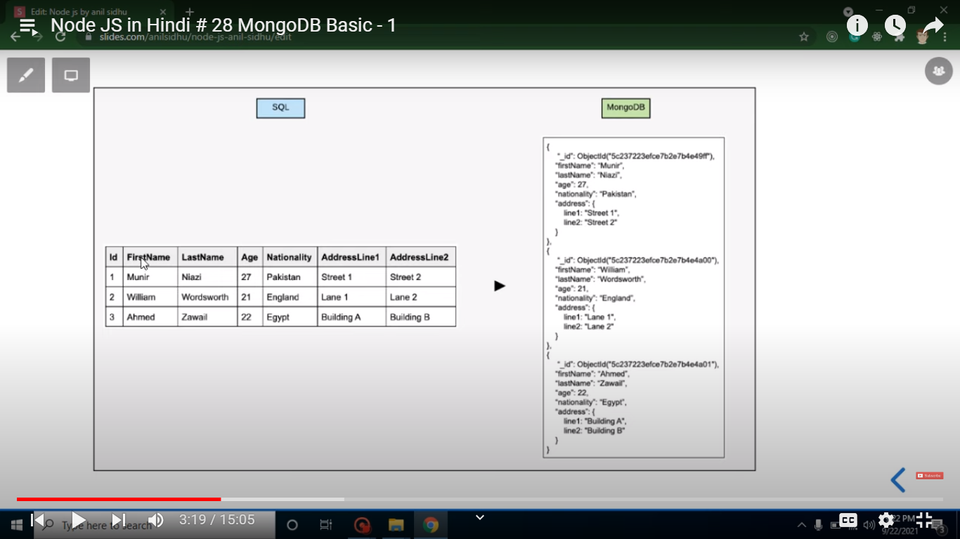

Set bin folder env variable path

Mongod- to start server

Mongosh – to start shell

**Commands:**

**>show dbs**

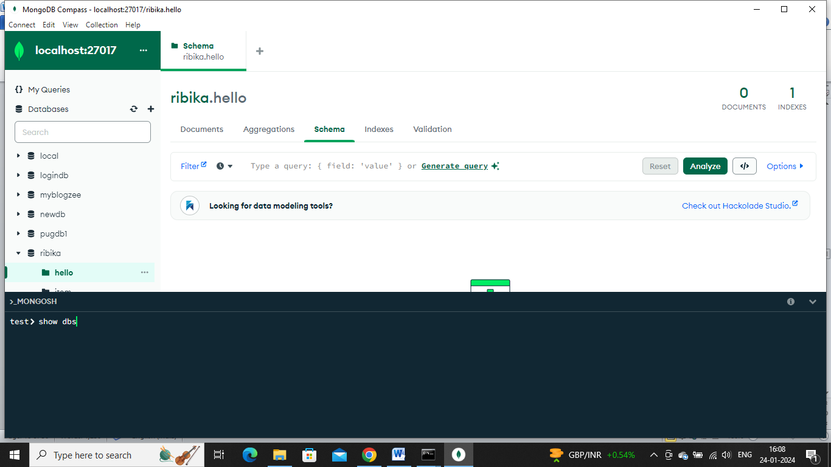

**The above is a mongoshell in mongodb compass**

**Create db:**

**>use dbname**

**Until atleast one collection in db, it will not be visible.**

**>show dbs;**

**>db.createCollection(‘table1’);**

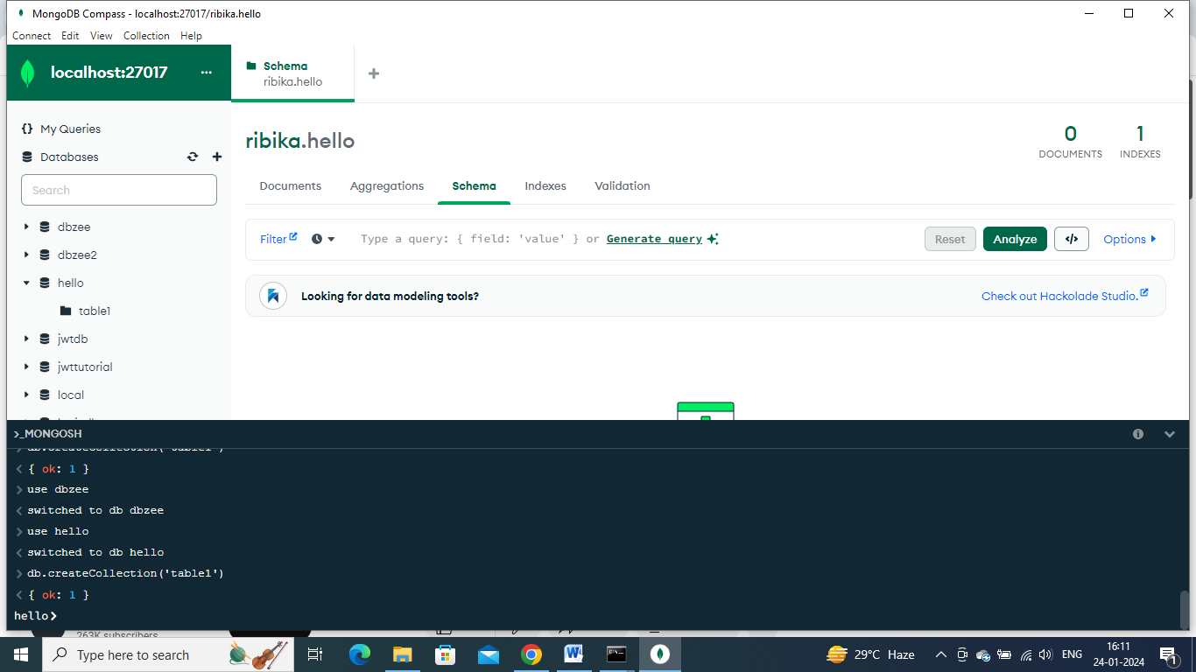

**>show dbs;**

**Show collections;**

**Db.collectionname.drop();**

**Db.table1.drop();**

**To check on which db we are working on now**

**>db**

**To delete a database:**

db.dropDatabase();

**CRUD operations:**

>use ecom

switched to db ecom

ecom>db.products.insertone({name:’jd’,brand:’jhhfjf’,price:788})

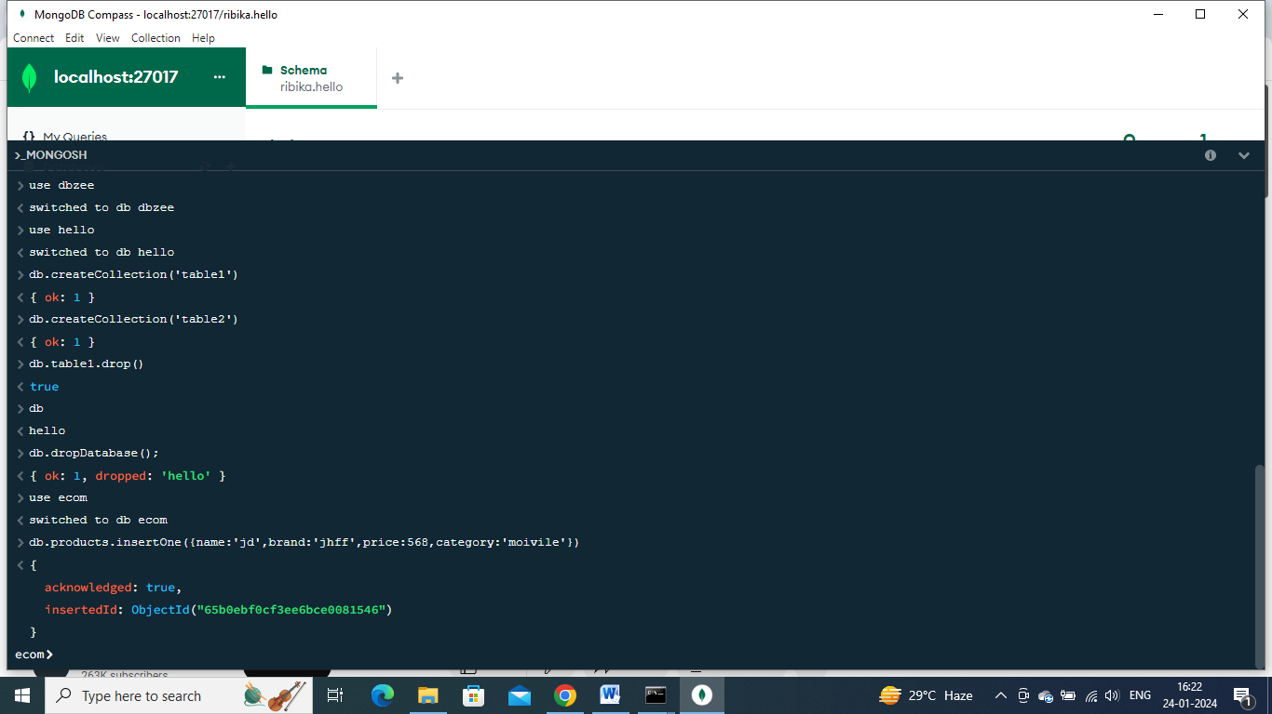

**Other way:**

Add data>insert document

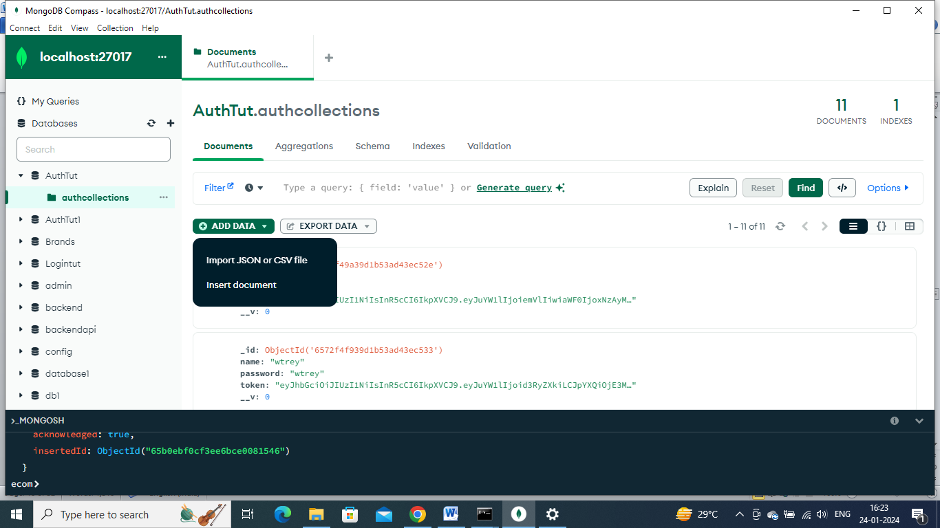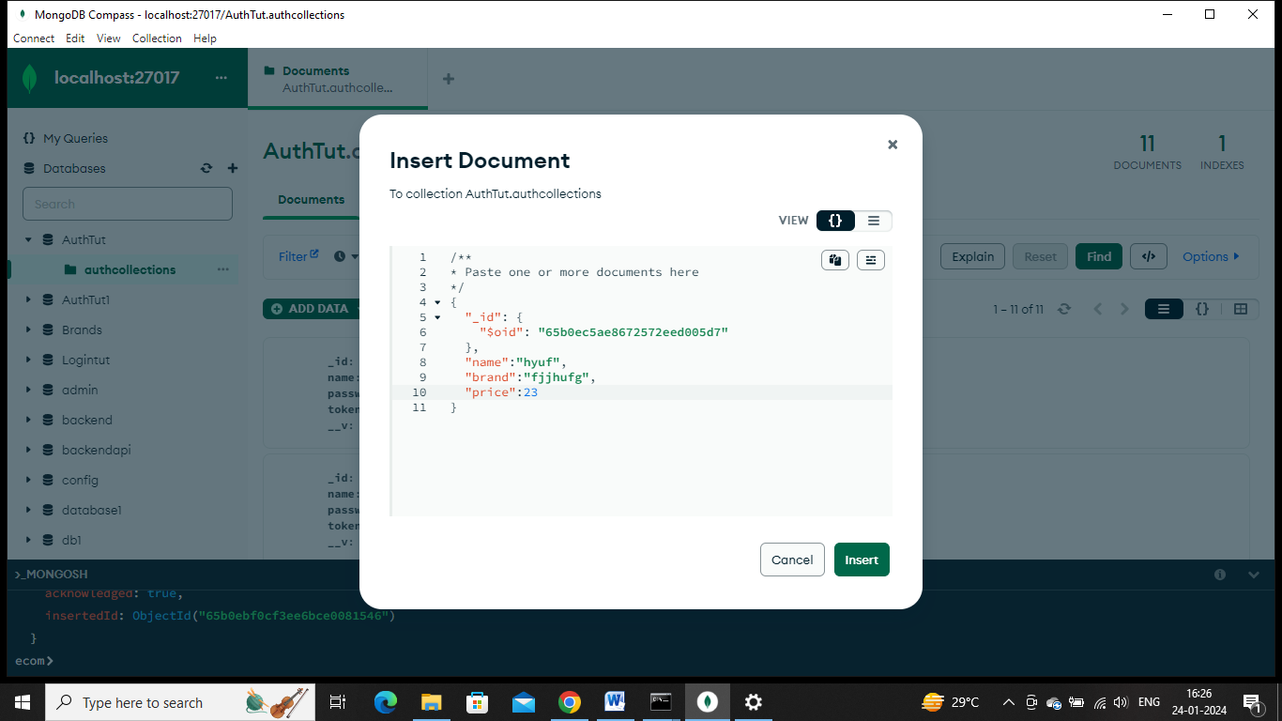

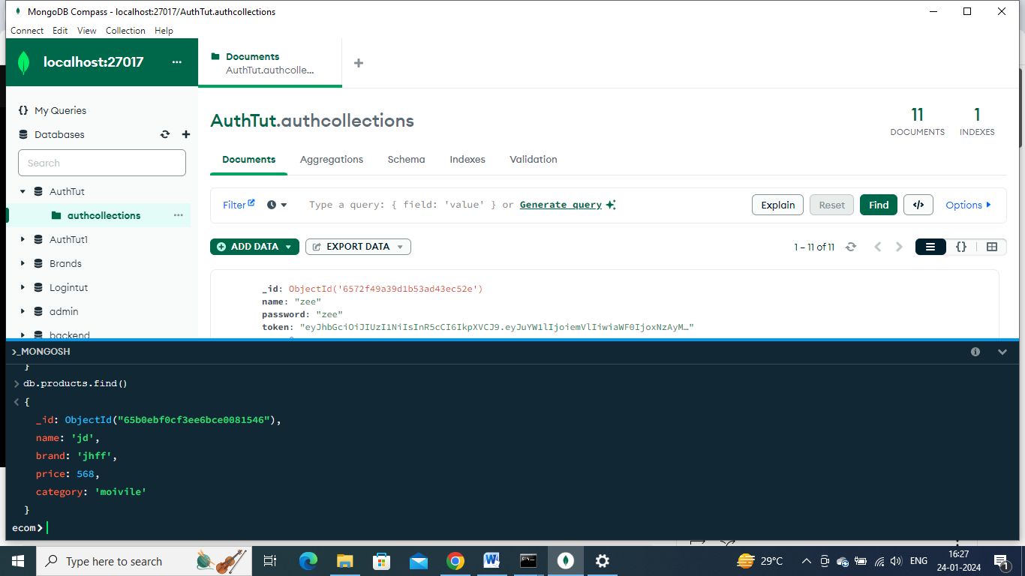

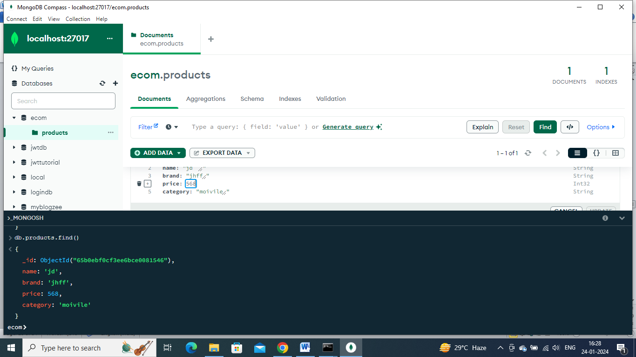

Can edit easily like this and refresh in gui

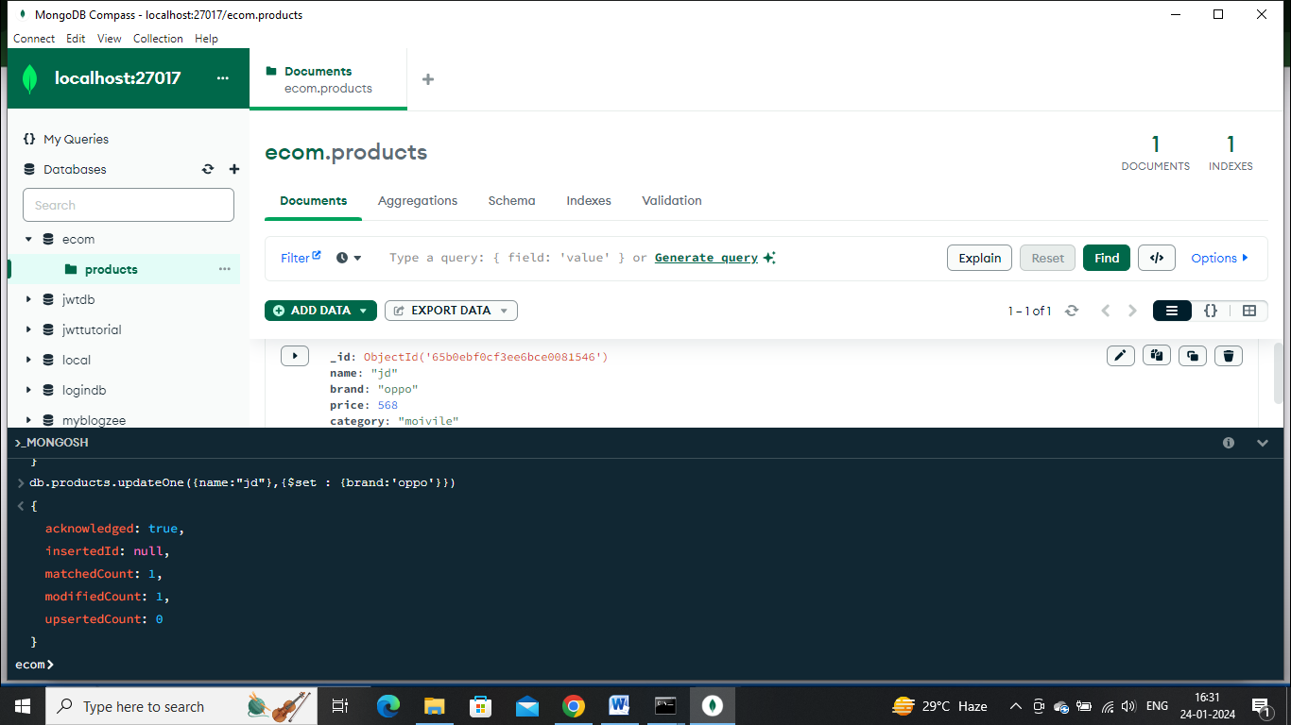

Delete:

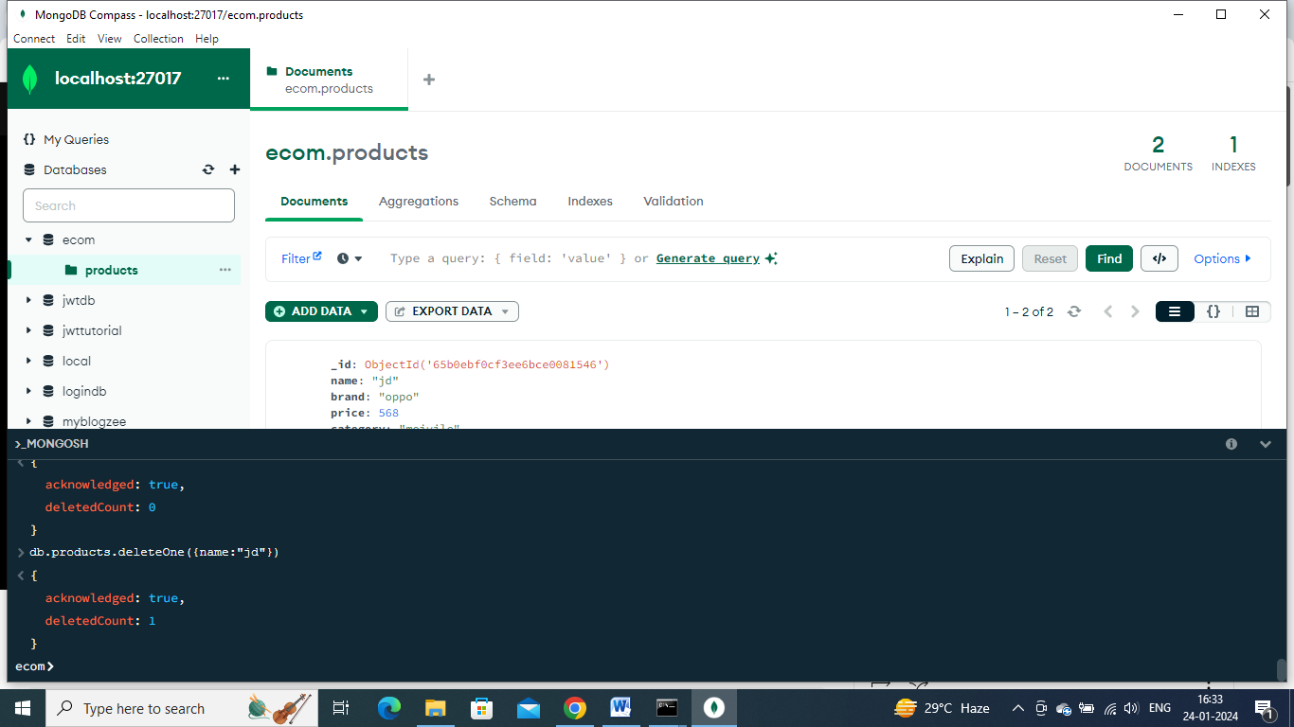

**Day 60: connecting mongodb with nodejs**

, Under the hood, mongoose uses mongoClient to connect to the server;

However, I can tell you few differences between these two connects;

* mongoose returns promise, mongoclient returns null
* mongoose connect is backed by an internal configurable connection pool

These are the 2 differences

MongoDB has fewer restrictions on data structure, allowing for more flexibility but potentially making it harder to enforce data consistency. Mongoose enables developers to define data models with fields, data types, validation rules, and default values, making it easier to ensure data consistency and integrity.

MongoDB is ideal for projects where data structures may evolve frequently, and where handling unstructured data or real-time analytics is paramount. On the other hand, Mongoose is a better fit for applications that demand a consistent data model, extensive data validation, and a more organized data management approach.

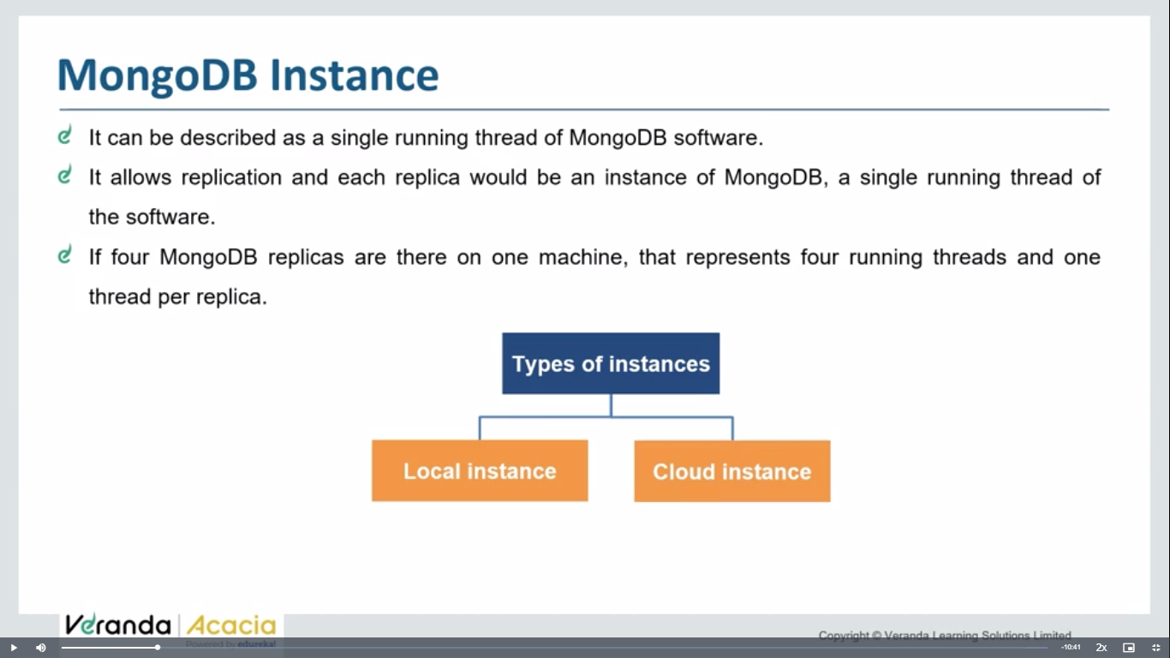 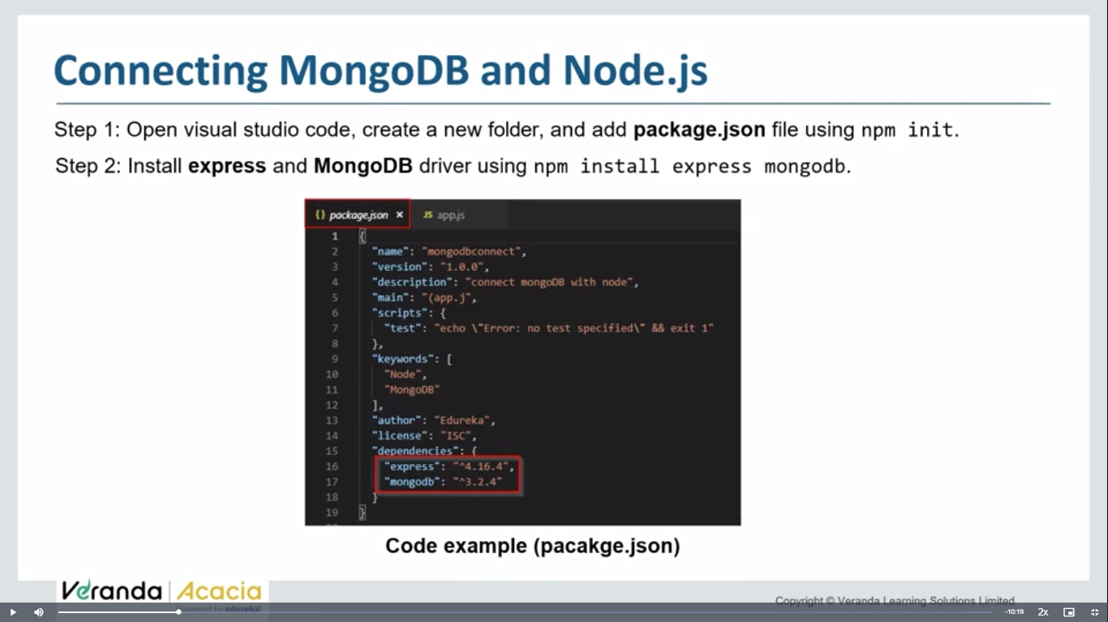 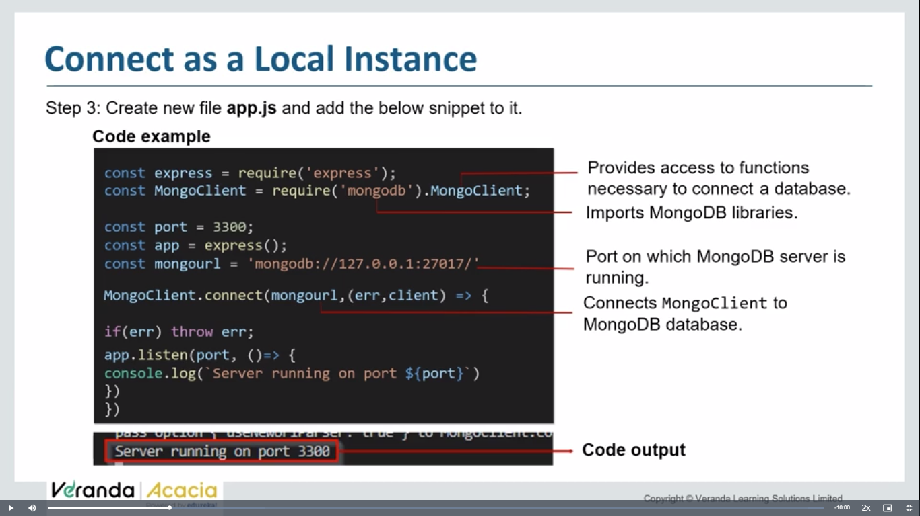 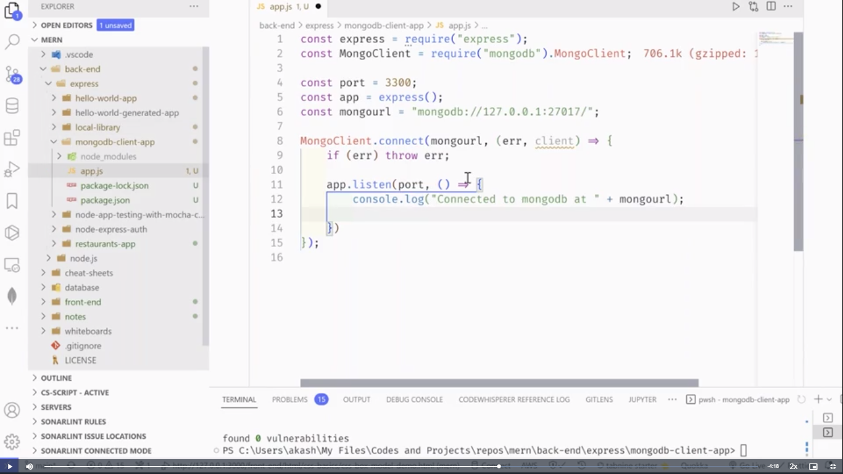

const express=require('express');

const mon=require('mongodb').MongoClient; //require mongoclient package from mongodb

const host='mongodb://localhost:27017/databse ';

const app=express();

// const database1='Akdb'

// const client=new mon(host);

function one(){

    const var1=new mon(host).connect();//.connect is to connect host and MongoClient

    // const data=var1.db(database1);

    console.log('database connected');

    // const collect=data.collection('pandu');

    // console.log(collect);

}

one();

app.listen(3005, ()=>{

    console.log("server started on ports");

});

* **Explanation- connect node with mongodb using mongoclient: refer search as mongodb npm**

**https://www.npmjs.com/package/mongodb**

**step1: Npm I mongodb – install mongodb package**

**step2:Import mongodb package**

// npm i mongodb

const {MongoClient} =require('mongodb');

(or)

const {MongoClient}=require('mongodb').MongoClient

// npm i mongodb

const {MongoClient} =require('mongodb');

// (or)

// const {MongoClient}=require('mongodb').MongoClient

const url='mongodb://localhost:27017';

//passing url to mongoclient

const client=new MongoClient(url);

 function getData(){

    let result=client.connect();

}

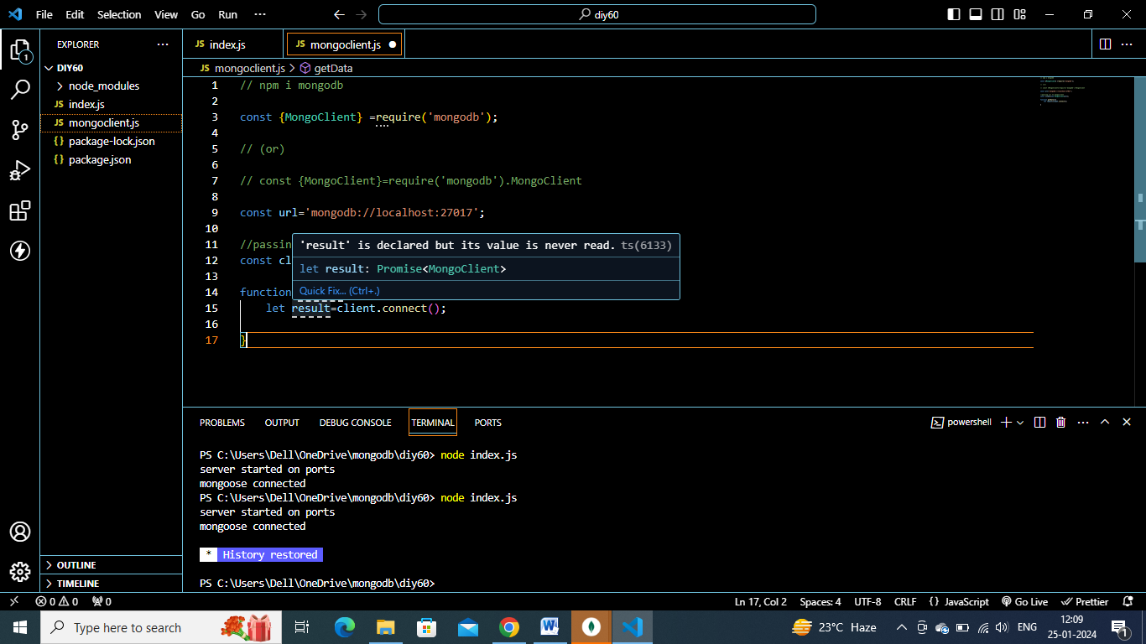

Client is returning a promise => it is timetaking to connect, so use await .

async  function getData(){

    let result= await client.connect();

}

getData();

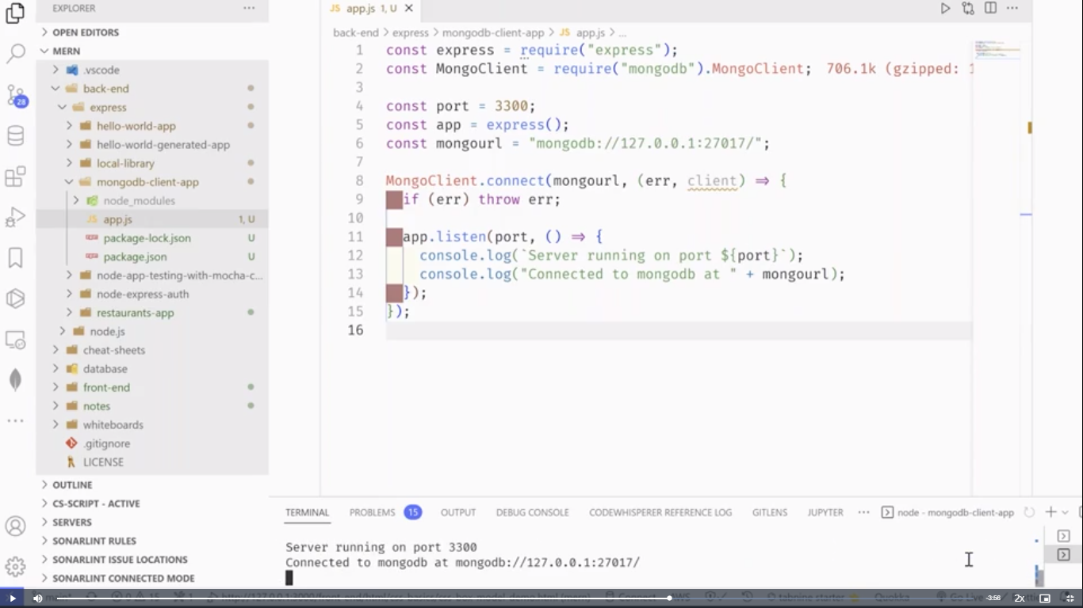 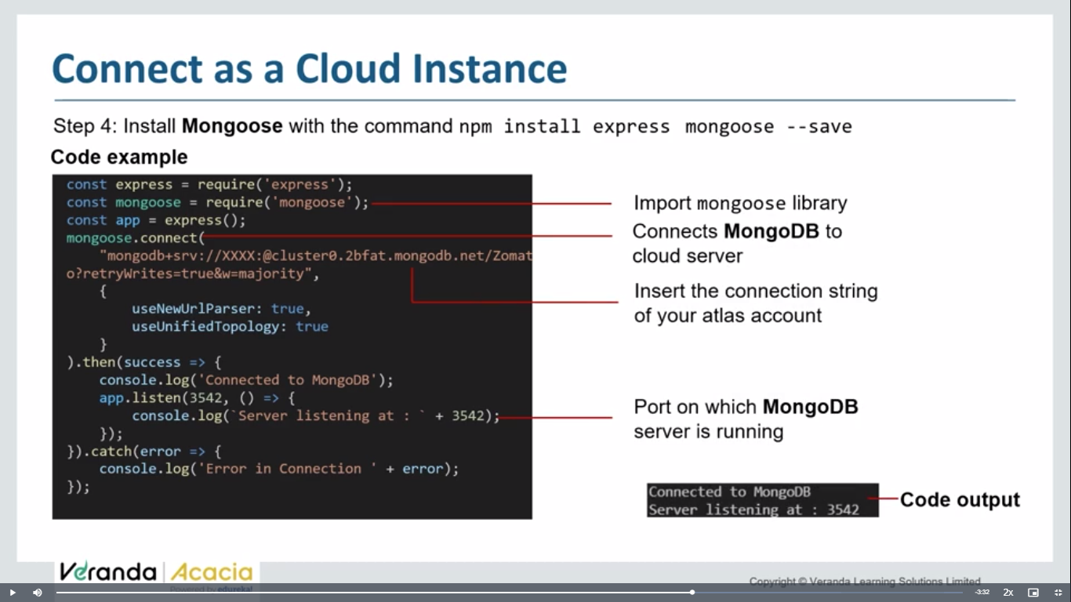 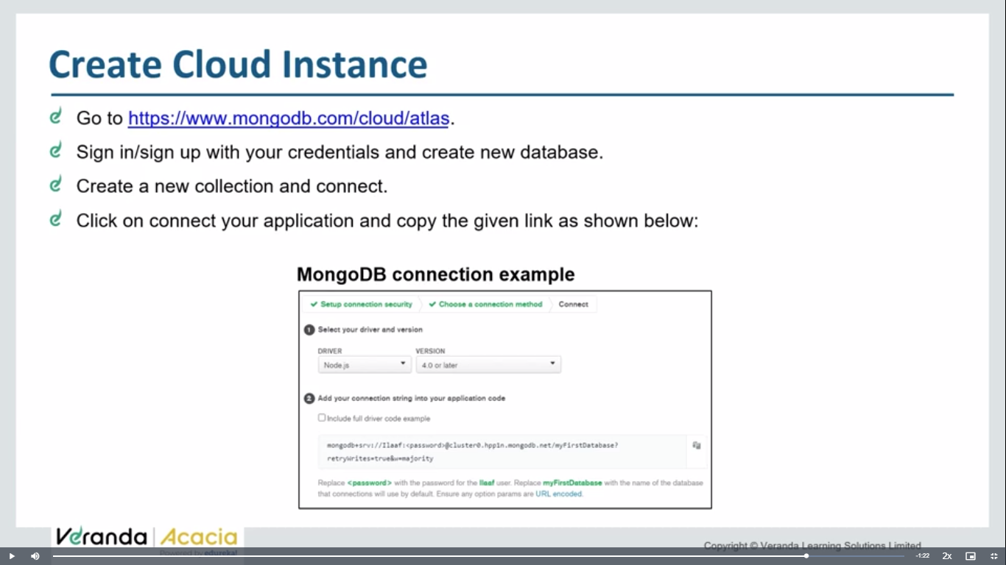

Npm I mongoose

const express=require('express');

const mongoo=require('mongoose');

const app=express();

app.listen(3542, ()=>{

    console.log('server started on ports');

});

mongoo.connect('mongodb://localhost:27017/cloudconn')

    .then(()=>console.log('mongoose connected'))

    .catch((err)=>console.log('err:'+err));

It wont display the db in mongodb compass until and unless , a collection is added into it.

Signup and register for mongodb atlas- <https://www.mongodb.com/cloud/atlas/register\>

**Mongoose tutorial:**

**Mongoose vs mongodb**

**Open mongodb npm in chrome**

**Open mongoose npm in chrome**

Mongodb is a official mongodb driver package- but has some limitations which will be overcomed by mongoose.

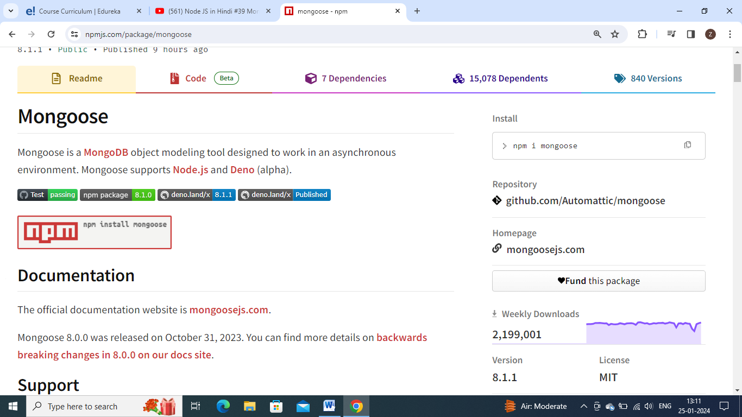

Mongoose is a **[MongoDB](https://www.mongodb.org/)** object modeling tool designed to work in an asynchronous environment. Mongoose supports [**Node.js**](https://nodejs.org/en/) and **[Deno](https://deno.land/)** (alpha).

Mongoose give some advance features like model and schema we can define. We can define structure.

We can define datatypes in mongoose. And we can apply validations in mongoose.

Npm I mongoose – install mongoose package.

Open mongodb compass and explain that we cannot enter extra column, and we cannot enter different datatype value.

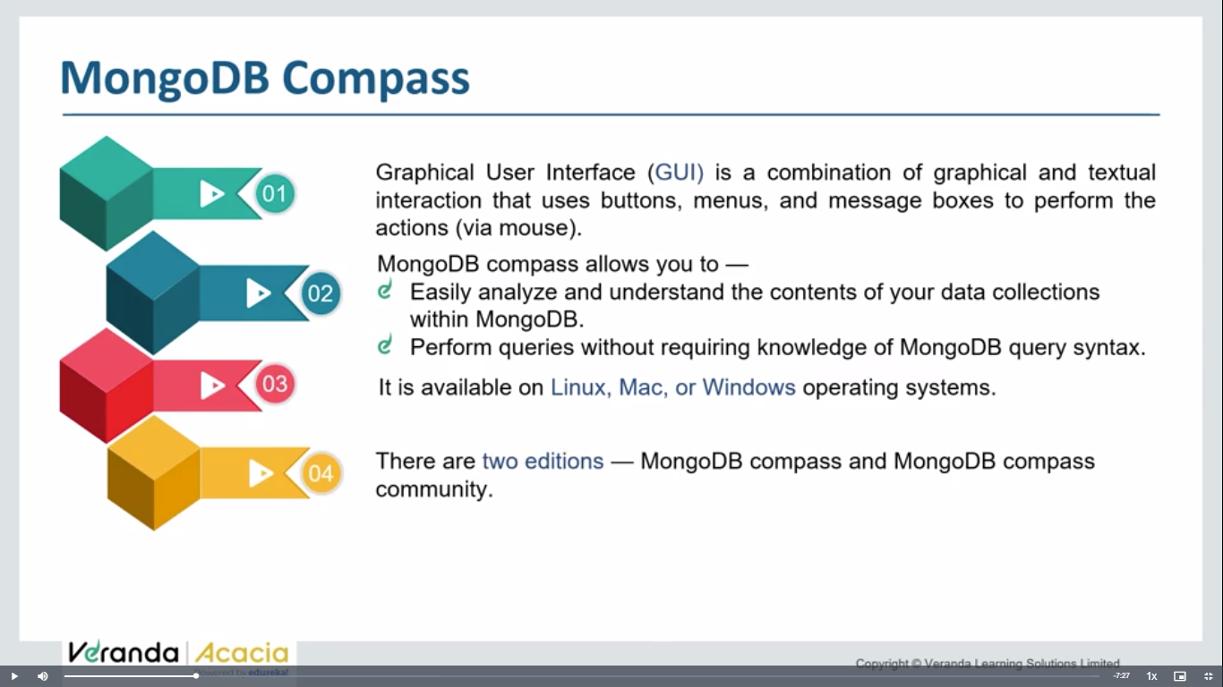

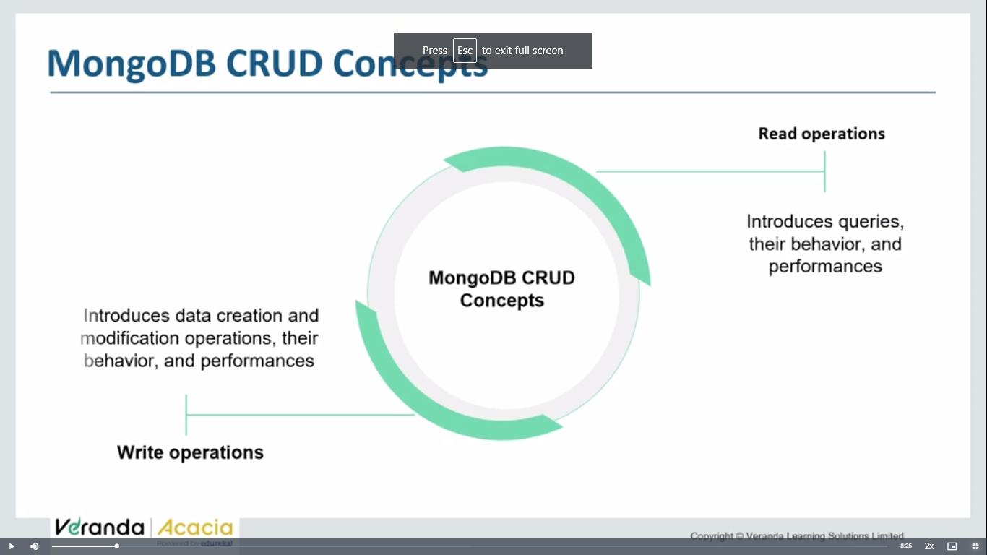 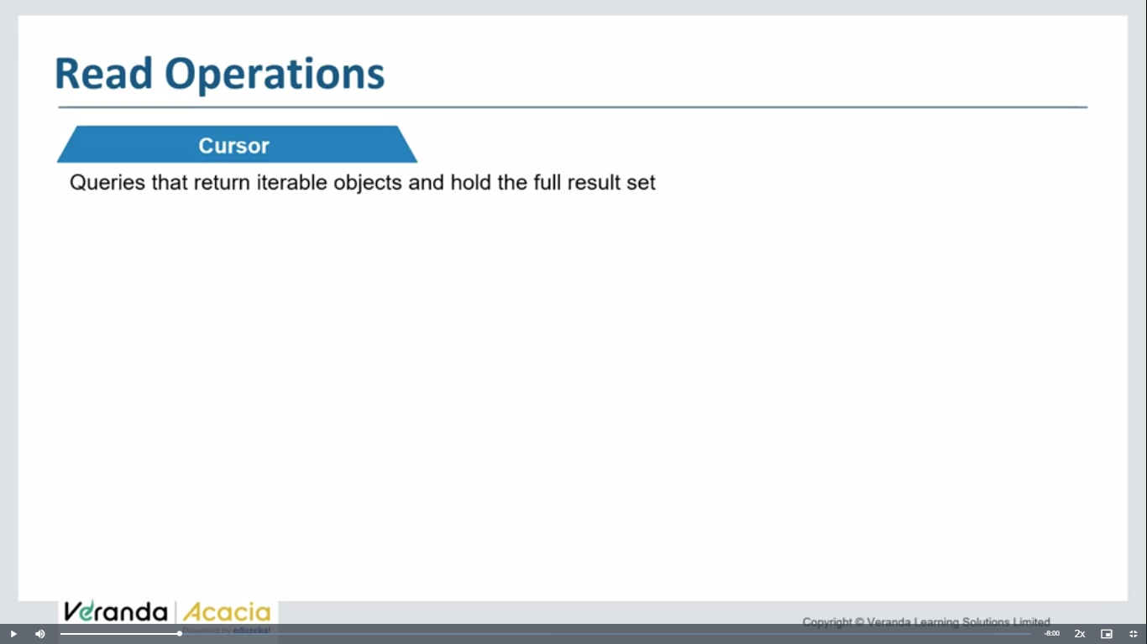

Whenever, u perform a find operation , it returns a iterable obj – which contains address of all records which included in result ser of query

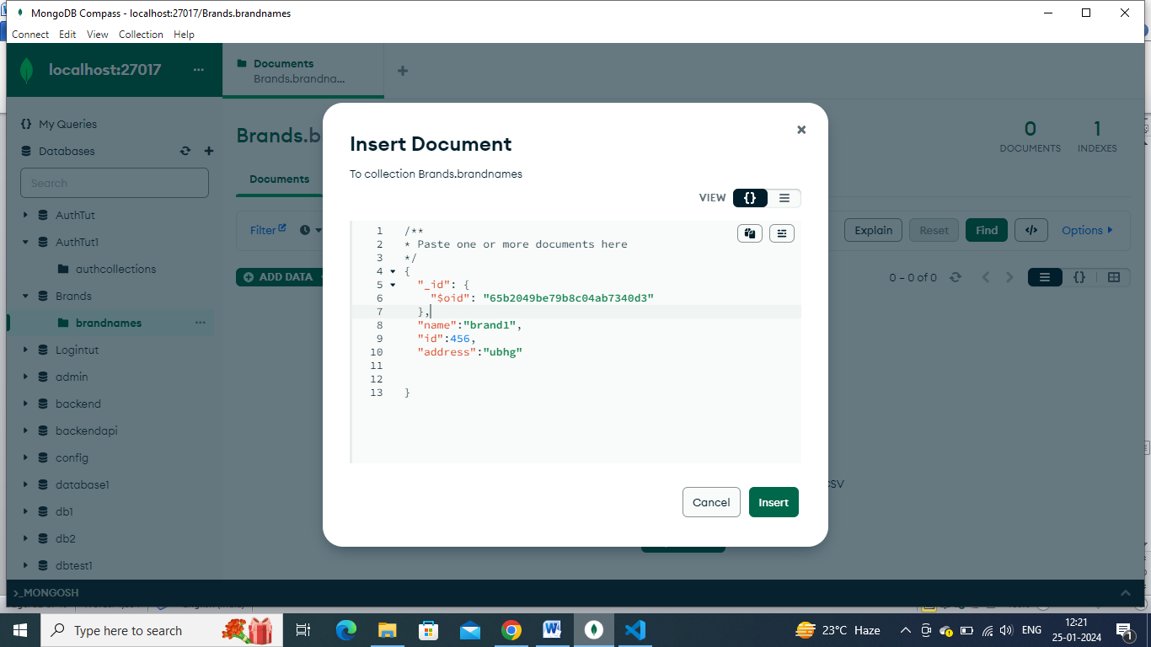

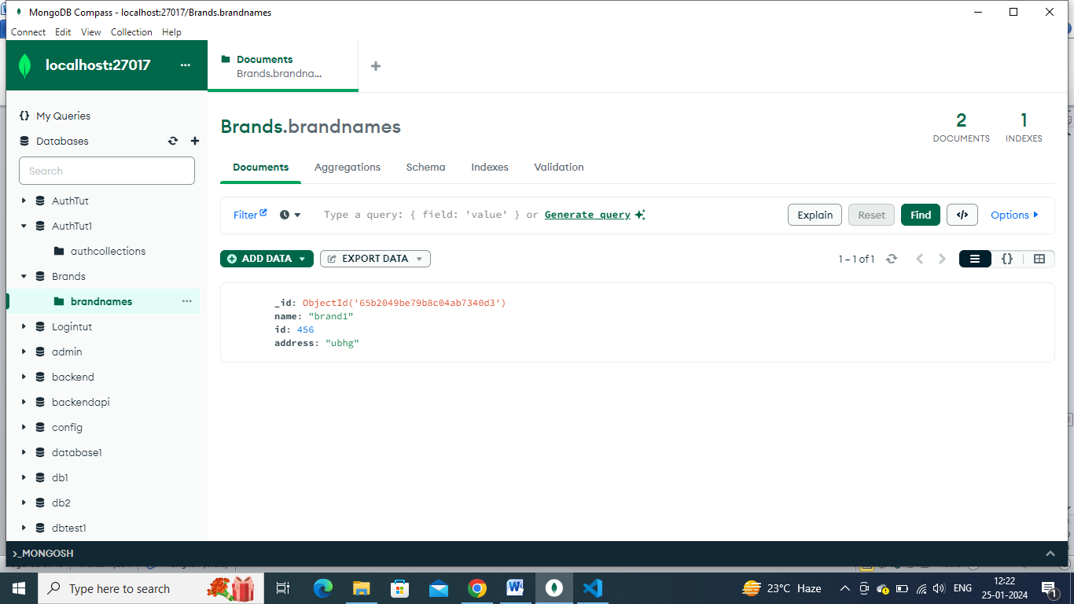

**Day 60 lu2-**

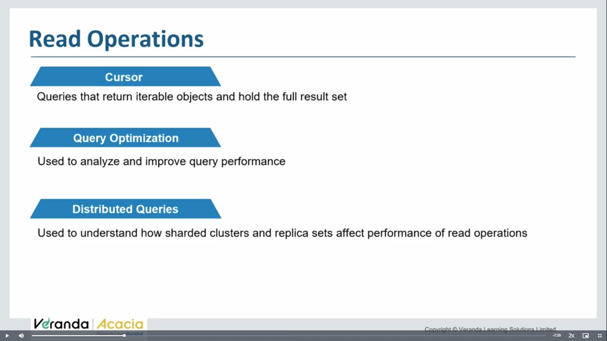

Distributed queries – when data shored on multiple physical db servers .

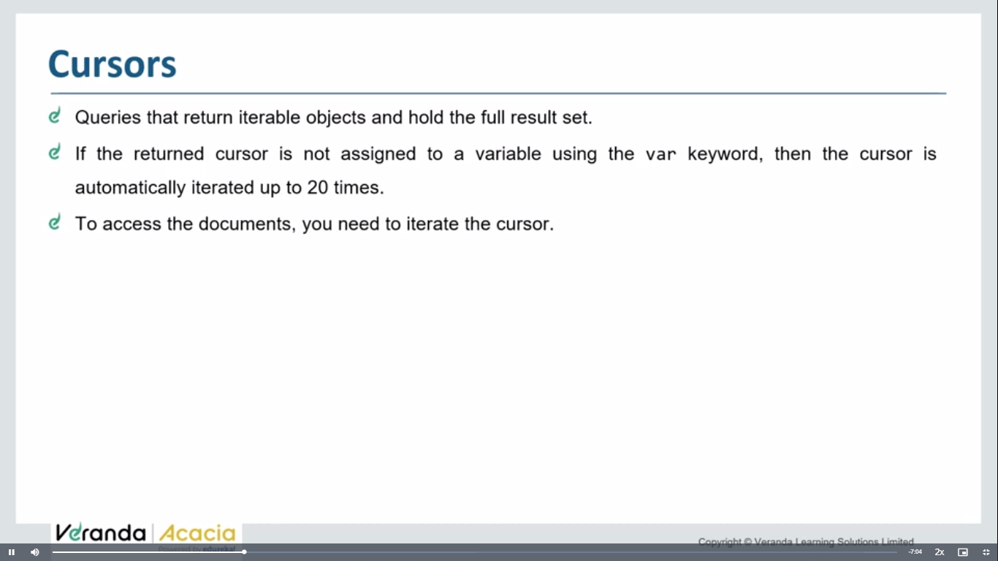

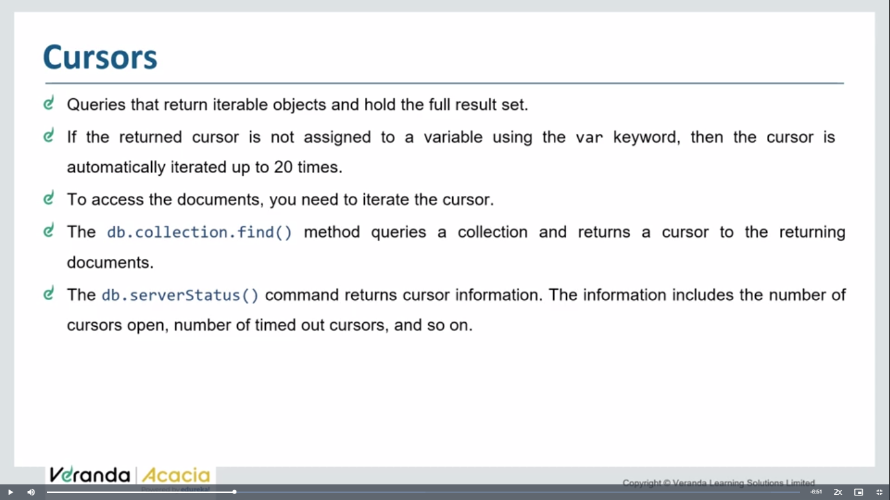 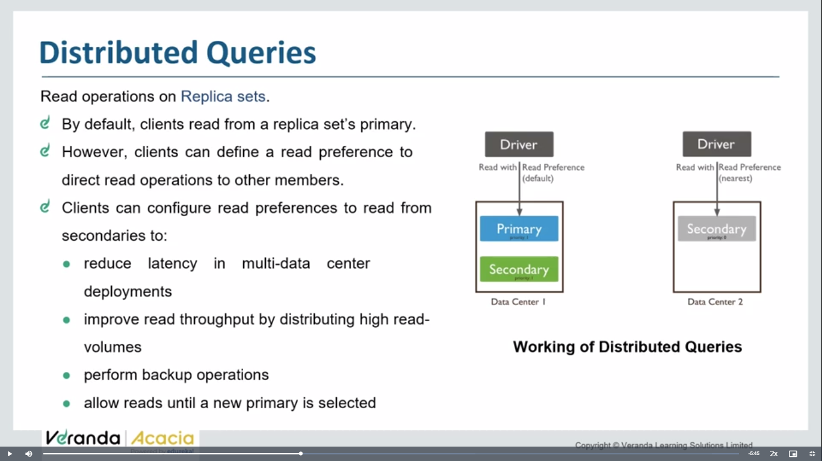 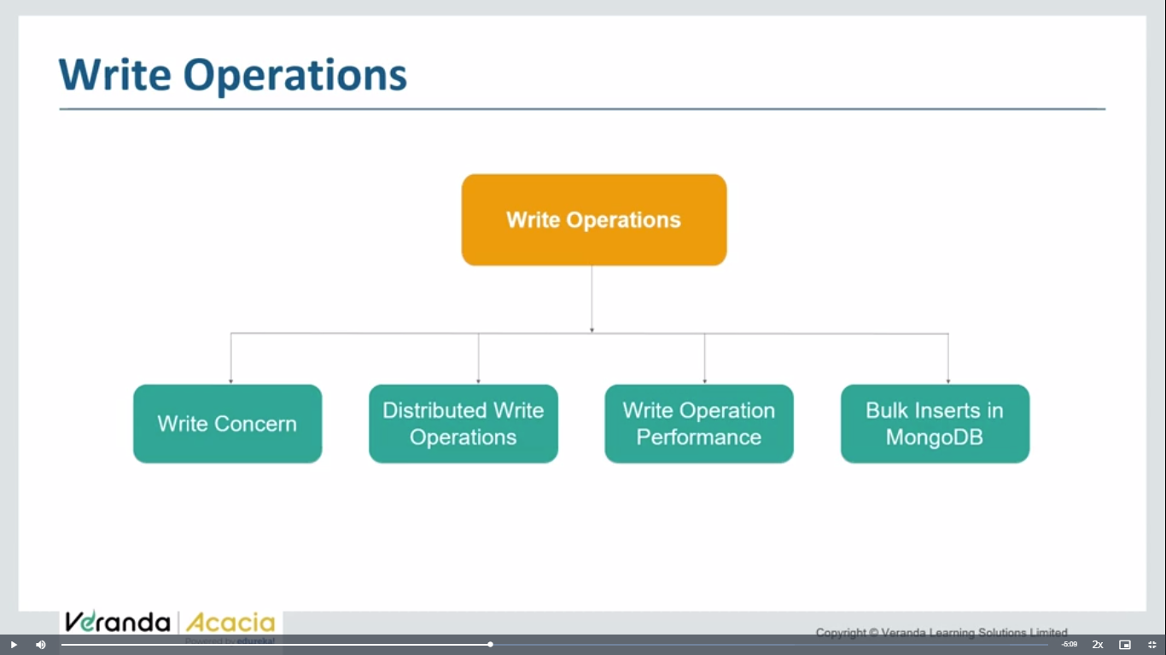 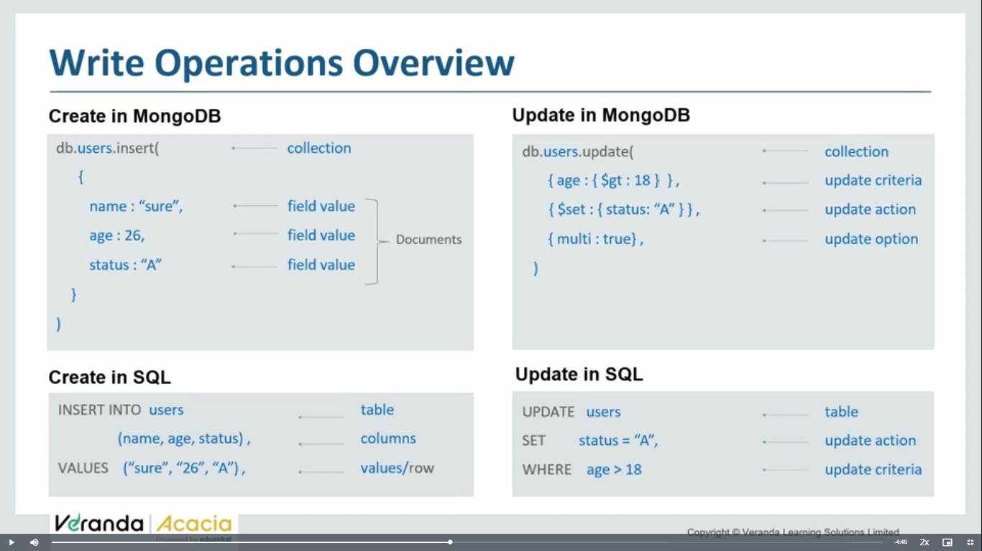 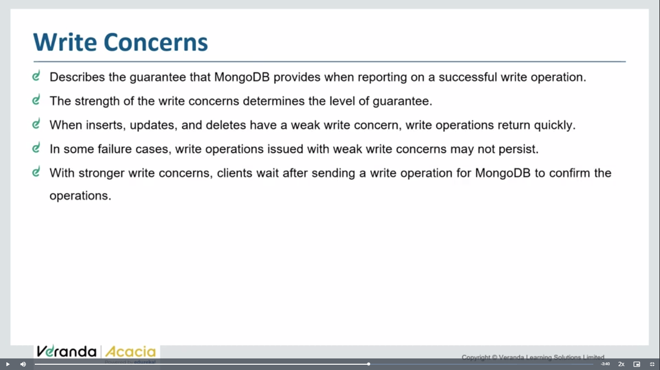 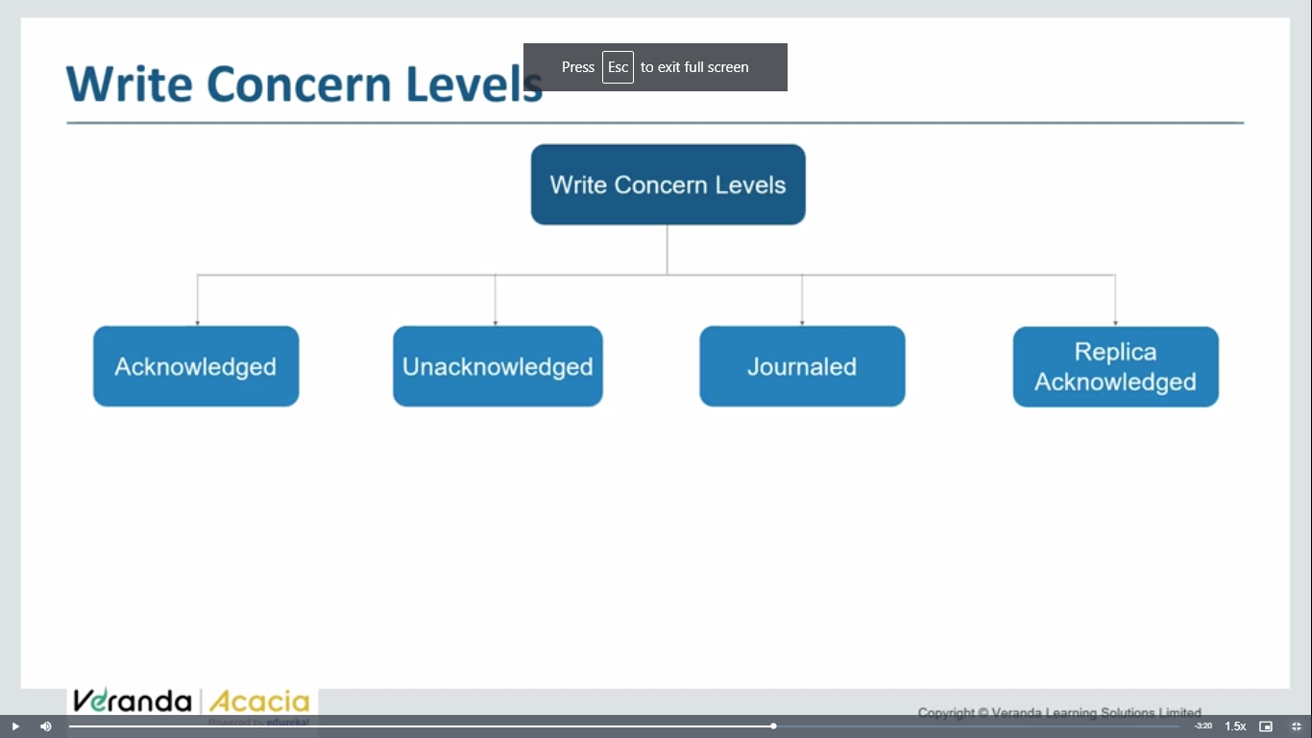

Ack- operation performed

Unack- we don’t know the status of operation

Journaled- log of operation

Replica ack- if u have replica sets – operations applied on all replica sets

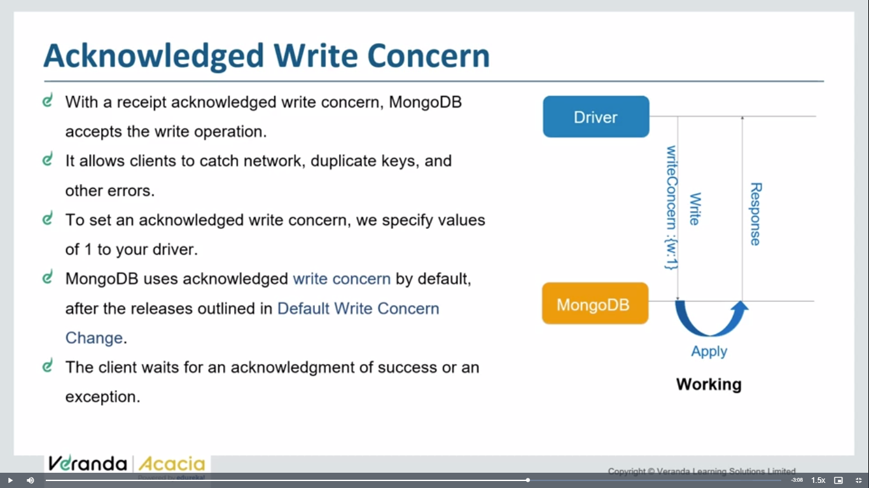 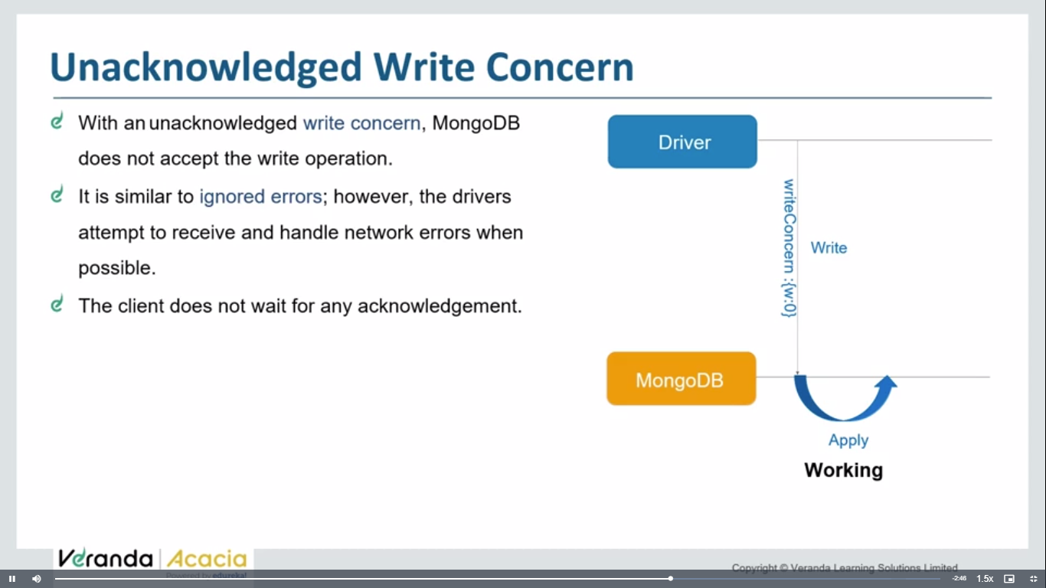 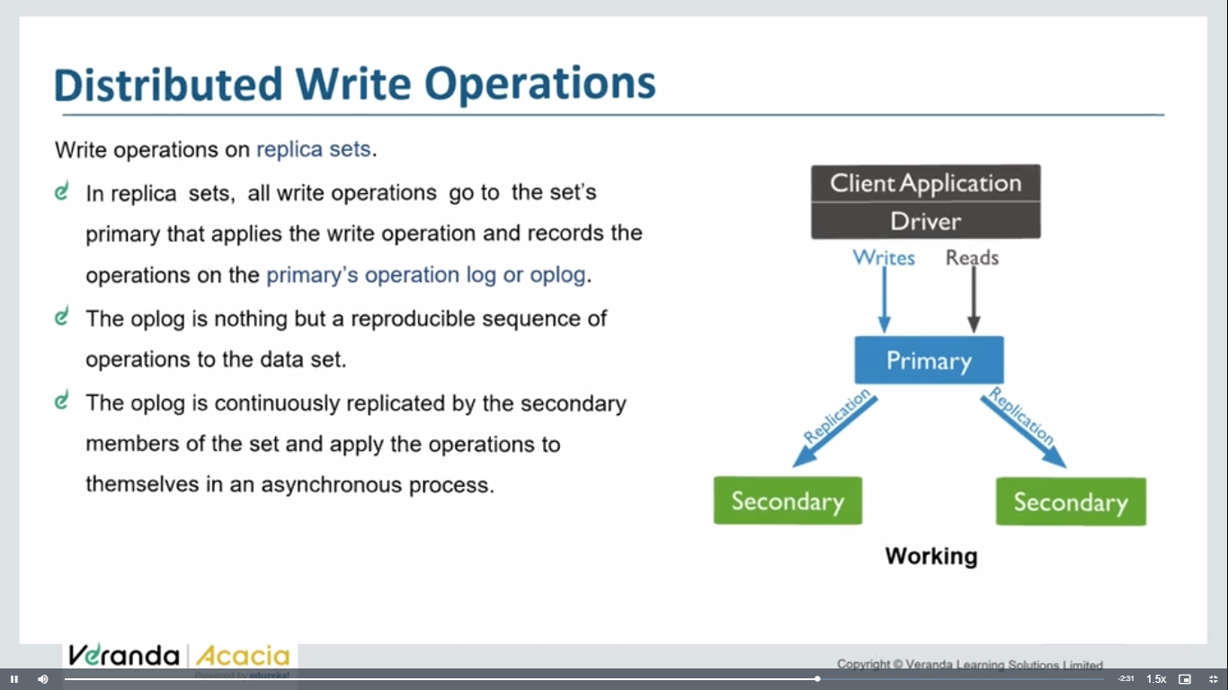 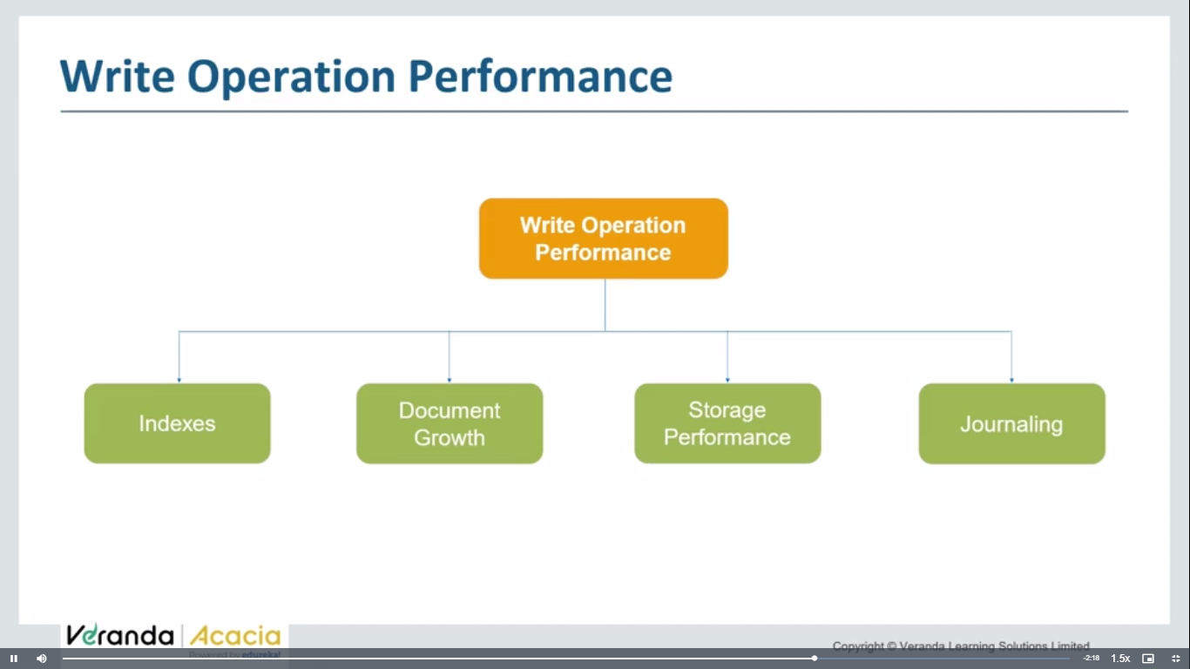 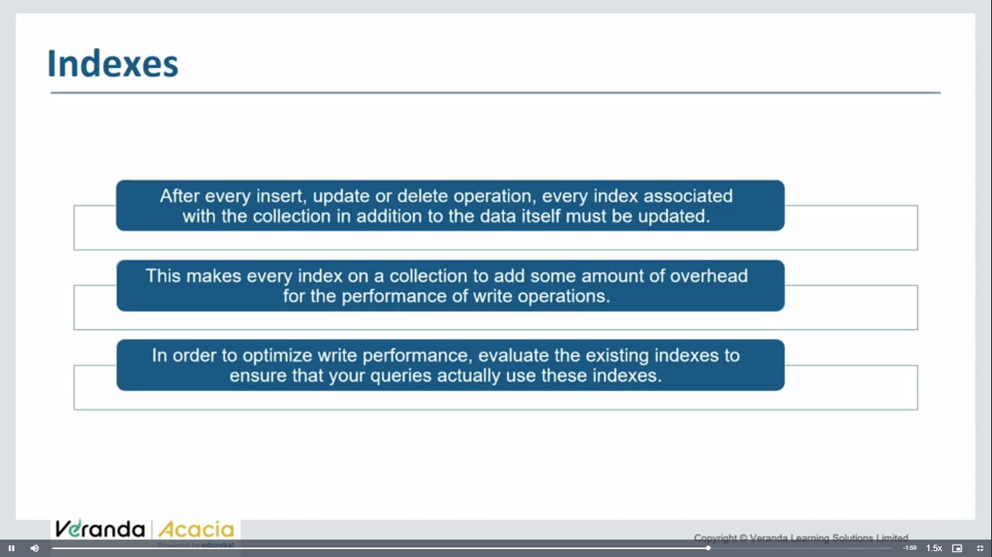hash table type of index

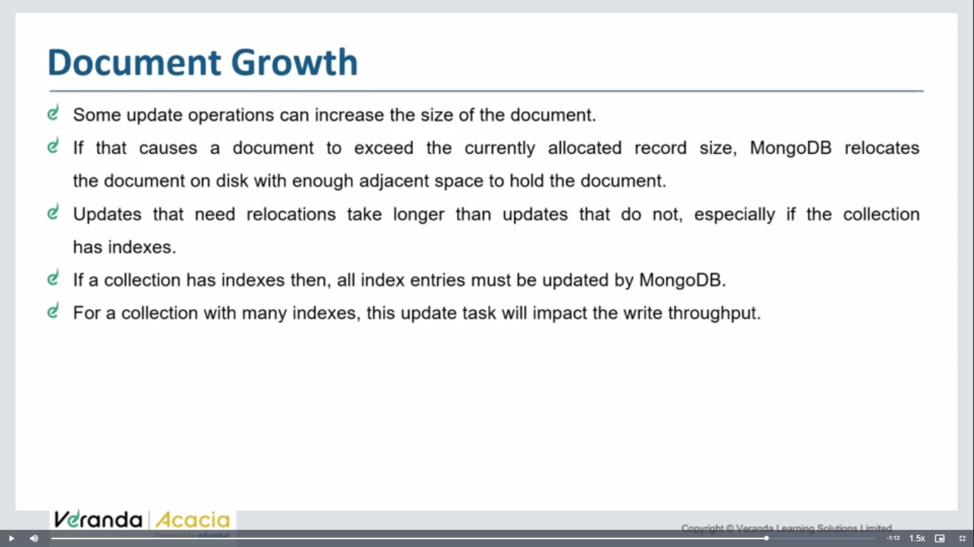

Do not let to increase no of indices increase too many

